Cloud Security Posture Management (CSPM) with Endpoint Detection & Response (EDR)
Introduction
Cloud computing has become the backbone of modern IT infrastructure, enabling organizations to deploy applications rapidly, scale resources efficiently, and reduce operational costs. However, as organizations increasingly migrate sensitive data and workloads to cloud environments, security challenges have grown significantly. Misconfigurations, unauthorized access, insecure APIs, and endpoint attacks are among the most common causes of cloud security breaches. To address these challenges, organizations adopt advanced security solutions such as Cloud Security Posture Management (CSPM) and Endpoint Detection & Response (EDR).
Cloud Security Posture Management focuses on continuously monitoring cloud environments to identify security risks, misconfigurations, and compliance violations. Many cloud breaches occur not because of vulnerabilities in the cloud provider but due to incorrect configuration by users, such as open storage buckets, weak identity policies, or exposed services. CSPM tools help organizations detect and remediate these issues before attackers can exploit them.
Endpoint Detection & Response, on the other hand, focuses on protecting endpoints such as servers, virtual machines, containers, and user devices. As cloud workloads often interact with endpoints, attackers frequently target endpoints to gain unauthorized access or execute malicious code. EDR solutions provide continuous monitoring, threat detection, incident investigation, and automated response capabilities to stop attacks in real time.
By integrating CSPM with EDR, organizations achieve a unified cloud security approach that covers both cloud infrastructure security and endpoint-level threat detection. This combined model ensures better visibility, faster incident response, improved compliance, and stronger overall security posture.

Cloud Security Posture Management (CSPM)
Cloud Security Posture Management is a security approach designed to continuously monitor cloud environments and ensure that configurations follow security best practices and regulatory standards. CSPM solutions analyze cloud resources such as virtual machines, storage services, databases, networking components, and identity access policies across public, private, and hybrid clouds.
One of the main objectives of CSPM is to detect misconfigurations. Examples include publicly accessible databases, unrestricted firewall rules, unused but active credentials, and lack of encryption for sensitive data. These misconfigurations are often accidental but can lead to severe data breaches if not addressed promptly. CSPM tools automatically scan cloud accounts and compare configurations against predefined security baselines.
CSPM also plays a critical role in compliance management. Many organizations must comply with regulations such as ISO 27001, GDPR, HIPAA, and PCI-DSS. CSPM continuously checks cloud configurations against compliance frameworks and generates audit-ready reports. This reduces manual effort and ensures continuous compliance instead of periodic checks.

Endpoint Detection & Response (EDR)
Endpoint Detection & Response is a cybersecurity solution designed to detect, investigate, and respond to threats on endpoints in real time. In cloud environments, endpoints include virtual machines, cloud servers, containers, and employee devices accessing cloud resources. Attackers often target these endpoints using malware, ransomware, phishing attacks, or credential theft techniques.
EDR continuously collects telemetry data from endpoints, such as process execution, file changes, network activity, and user behavior. This data is analyzed using behavioral analytics and threat intelligence to identify suspicious activities. Unlike traditional antivirus solutions, EDR can detect advanced threats that use fileless attacks or zero-day vulnerabilities.
When a threat is detected, EDR enables rapid response actions. These actions may include isolating the infected endpoint, terminating malicious processes, blocking network connections, or rolling back harmful changes. Security teams can also perform detailed forensic analysis to understand how the attack occurred and prevent future incidents.
EDR improves incident response efficiency by providing centralized dashboards and automated workflows. It reduces the time between detection and containment, which is critical in preventing lateral movement and data exfiltration. In cloud environments, where workloads are dynamic and scalable, EDR ensures continuous protection regardless of where endpoints are deployed.

Integration of CSPM with EDR
The integration of Cloud Security Posture Management with Endpoint Detection & Response creates a comprehensive cloud security architecture. While CSPM focuses on identifying and fixing cloud configuration issues, EDR focuses on detecting and responding to active threats at the endpoint level. Together, they provide end-to-end security visibility.
CSPM can identify risky configurations such as exposed virtual machines or overly permissive access controls. These findings can be correlated with EDR data to determine whether endpoints associated with those configurations are actively under attack. For example, if CSPM detects an exposed server and EDR detects suspicious activity on that server, security teams can immediately prioritize the incident.
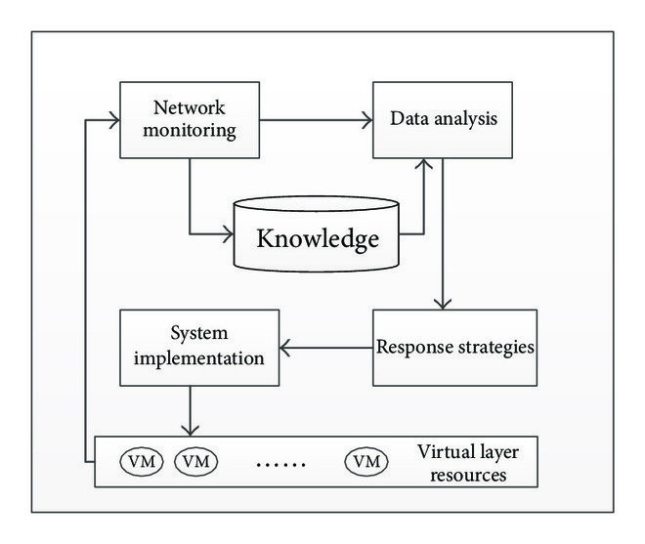

2. Requirements
- Hardware Requirements
Component | Minimum Requirement | Recommended Requirement | Purpose
Processor (Server / Cloud Instance) | Intel Core i5 / AMD Ryzen 5 / 2 vCPU | Intel Core i7 / 4 vCPU | Handles CSPM analysis and EDR processing
RAM (Server / Cloud Instance) | 8 GB | 16 GB or higher | Stores security data, logs, and runtime processes
Storage (Server) | 100 GB SSD | 250 GB SSD | Stores logs, reports, alerts, and audit data
Network Bandwidth | 50 Mbps | 100 Mbps or higher | Real-time monitoring and data transmission
System Architecture | 64-bit | 64-bit | Required for modern security tools
Endpoint Processor | Intel Core i3 | Intel Core i5 or higher | Runs EDR agents efficiently
Endpoint RAM | 4 GB | 8 GB | Supports endpoint monitoring
Endpoint Storage | 50 GB free | 100 GB free | Stores endpoint logs and security data
Backup Hardware (Optional) | External HDD / Cloud Backup | Dedicated Backup Server | Data recovery and disaster management
Load Balancer (Optional) | Software-based | Hardware / Managed LB | High availability and traffic distribution

Software Requirements
Category | Software / Technology | Description / Purpose
Operating System (Server) | Ubuntu 20.04 / 22.04 LTS, Windows Server 2019 / 2022 | Hosts CSPM and EDR services
Operating System (Endpoint) | Windows 10 / 11, Linux | Runs EDR agents
Cloud Platform | Amazon Web Services / Microsoft Azure / Google Cloud Platform | Cloud infrastructure hosting
CSPM Tool | Cloud Security Posture Management Solution | Monitors cloud misconfigurations and compliance
EDR Tool | Endpoint Detection & Response Agent | Detects and responds to endpoint threats
Programming Language | Python 3.x | Automation, scanning, and integration
Scripting Tools | Bash / PowerShell | System and security automation
Database | MySQL / PostgreSQL / SQLite | Stores security findings and reports
Web Technologies | HTML5, CSS3, JavaScript | Dashboard and reporting interface
API Technology | REST APIs | Integration between CSPM, EDR, and cloud
Security Frameworks | IAM, RBAC, SSL/TLS | Access control and data protection
DevOps Tools | Docker, Git | Deployment and version control
Browser | Chrome / Edge / Firefox | System access and monitoring

3. Why Cloud security is important?

1. What is Cloud Security?
Cloud security refers to a set of technologies, policies, controls, and practices designed to protect cloud-based systems, data, and infrastructure from cyber threats. It ensures that data stored in the cloud remains confidential, secure, and available only to authorized users.
➡️Example:
If a company stores customer data on Amazon Web Services and does not configure access rules properly, attackers can access sensitive data over the internet. Cloud security tools help prevent such incidents.

2. Why is Cloud Security Important?
Cloud security is important because organizations store highly sensitive information in the cloud, such as personal data, financial records, intellectual property, and business-critical applications. Any security breach can lead to financial loss, legal penalties, and damage to reputation.
Unlike traditional on-premises systems, cloud resources are accessible from anywhere. This increases flexibility but also increases security risks. Cloud security ensures safe usage of cloud services while maintaining performance and scalability.
➡️Example:
A healthcare organization storing patient records in the cloud must follow strict security laws. Without cloud security controls, patient data could be leaked, leading to legal action and loss of trust.

3. What Are the Major Threats in Cloud Environments?
Cloud environments face multiple security threats due to their open and dynamic nature. Some of the major threats include:
- Data Breaches
Unauthorized access to sensitive data stored in cloud storage or databases.
- Misconfiguration
Incorrect cloud settings such as open storage buckets or unrestricted network access.
- Account Hijacking
Attackers steal login credentials and gain control over cloud resources.
- Malware and Ransomware
Malicious software that infects cloud servers or endpoints.
- Insider Threats
Employees or users misusing access permissions intentionally or accidentally.
➡️Example:
An attacker exploits weak passwords of a cloud administrator account and deletes critical cloud data, causing service outage.
4. How Does Cloud Security Protect Data?
Cloud security protects data using multiple layers of security controls. These controls ensure that data remains protected both at rest and in transit.
Key data protection methods include:
- Encryption: Converts data into unreadable format
- Access Control: Limits data access to authorized users
- Backup and Recovery: Prevents data loss
- Monitoring and Logging: Tracks suspicious activity
➡️Example:
Even if attackers gain access to encrypted cloud storage, they cannot read the data without encryption keys.
5. Why Is Identity and Access Management (IAM) Important in Cloud Security?
Identity and Access Management (IAM) ensures that only authorized users can access cloud resources. IAM controls who can log in, what resources they can access, and what actions they can perform.
IAM is important because cloud platforms are accessed remotely. Weak identity controls can lead to unauthorized access.
Key IAM features:
- Multi-Factor Authentication (MFA)
- Role-Based Access Control (RBAC)
- Least Privilege Access
➡️Example:
A developer should not have permission to delete cloud databases. IAM ensures users only get access required for their role.
6. How Do Misconfigurations Affect Cloud Security?
Misconfigurations are one of the leading causes of cloud security breaches. They occur when cloud resources are incorrectly set up due to lack of knowledge or human error.
Common misconfigurations include:
- Publicly accessible storage
- Open firewall ports
- Over-permissive access roles
- Disabled logging
Cloud security tools automatically detect and correct these misconfigurations.
➡️Example:
A company accidentally makes its cloud storage public. Hackers download confidential customer data within minutes.

7. Why Is Cloud Security Important for Compliance?
Organizations must follow legal and regulatory standards to protect user data. Cloud security ensures compliance with standards such as data privacy laws and industry regulations.
Cloud security helps by:
- Monitoring compliance continuously
- Generating audit reports
- Enforcing security policies
Failure to comply can result in heavy fines and legal issues.
➡️Example:
A financial institution storing payment data must comply with strict security standards. Cloud security tools ensure compliance automatically.

4. Uses of Cloud Security Posture Management (CSPM) with Endpoint Detection & Response (EDR)?

1. What is the main use of CSPM with EDR in cloud environments?
The main use of CSPM with EDR is to provide complete security visibility and protection across cloud infrastructure and endpoints. CSPM ensures that cloud resources are securely configured, while EDR detects and responds to threats occurring on servers, virtual machines, and user devices.
Example:
A company hosts its application on Amazon Web Services. CSPM detects that a database is publicly accessible, while EDR monitors the server and detects suspicious login attempts.

2. How does CSPM with EDR help in preventing cloud misconfigurations?
One of the most important uses of CSPM is identifying and correcting cloud misconfigurations. CSPM continuously scans cloud environments to ensure security best practices are followed. When combined with EDR, endpoints affected by misconfigurations are actively monitored for malicious activity.
Example:
A cloud storage bucket is mistakenly made public. CSPM raises an alert, and EDR monitors systems accessing the bucket. If a malicious IP attempts data download, EDR blocks the activity.

3. How does CSPM with EDR improve threat detection and response?
CSPM provides environmental context, such as exposed assets and risk severity, while EDR provides behavioral analysis by monitoring endpoint activities. This combined information allows security teams to detect threats faster and respond more accurately.
Example:
CSPM identifies a cloud VM exposed to the internet. EDR detects malware execution on that VM. The system automatically isolates the VM and prevents further spread.

4. How is CSPM with EDR used for compliance management?
Many organizations must follow regulatory standards such as data protection laws. CSPM ensures that cloud configurations meet compliance requirements, while EDR ensures endpoints are not compromised.
Example:
A finance company must protect transaction data. CSPM verifies encryption and access policies, while EDR ensures no unauthorized processes access sensitive data.

5. How does CSPM with EDR protect cloud workloads and servers?
Cloud workloads such as virtual machines, containers, and databases are frequent attack targets. CSPM secures these workloads by enforcing correct configurations, and EDR protects them by monitoring runtime behavior.

6. How is CSPM with EDR used in multi-cloud environments?
Many organizations use multiple cloud platforms. CSPM provides centralized visibility across all cloud environments, while EDR ensures endpoint protection across different platforms.
This unified approach reduces complexity and security gaps.

7. How does CSPM with EDR help in ransomware prevention?
Ransomware attacks often start at the endpoint level and spread to cloud resources. EDR detects ransomware behavior early and stops it, while CSPM ensures cloud backups and access controls are properly configured.
Together, they minimize damage and ensure fast recovery.

5. Types of web Application for cloud security posture management ?
- SaaS-Based Secure Web Applications
Security Description
SaaS-based CSPM applications are hosted and managed by third-party cloud vendors. Organizations access the security dashboard via secure web browsers using HTTPS protocols.
These platforms are designed with:
- Strong encryption (SSL/TLS)
- Multi-Factor Authentication (MFA)
- Role-Based Access Control (RBAC)
- Secure API integrations
Security Benefits
- Continuous cloud configuration scanning
- Automatic updates with latest security patches
- Built-in threat intelligence
- Centralized monitoring across multiple cloud accounts
Logical Security Example
An organization using Amazon Web Services connects its cloud account to a SaaS CSPM platform. The web application detects that an S3 storage bucket is publicly accessible.
Immediately:
- The dashboard displays a critical alert.
- The system suggests remediation.
- The administrator receives an email notification.
This prevents data leakage before attackers exploit it.
Security Use Case
Best for companies needing scalable, real-time security monitoring without maintaining infrastructure.

- On-Premise Secure Web Applications
Security Description
On-premise CSPM web applications are installed within an organization’s internal network or private cloud. These systems do not rely on external SaaS vendors.
Security control remains fully under the organization.
Security Features
- Internal hosting behind firewall
- Data encryption at rest
- Custom security policy enforcement
- Restricted network access
- Integration with internal SIEM systems
Logical Security Example
A government organization handling classified data cannot allow external SaaS access. It deploys an internal CSPM web system.
If a firewall rule exposes a sensitive server:
- The internal dashboard alerts the security team.
- Logs remain within the secure data center.
- No data leaves the organization.
Security Use Case
Ideal for defense, banking, and healthcare industries with strict compliance requirements.

Hybrid Security Web Applications

Security Description

Hybrid CSPM web applications combine SaaS-based and on-premise models. Sensitive data is stored internally, while non-sensitive analytics are processed in the cloud.

Security Advantages

Balanced data protection

Scalable security operations

Centralized web-based visibility

Flexible compliance management

Logical Security Example

A multinational company uses:

Microsoft Azure for applications

Internal private cloud for confidential logs

The hybrid CSPM dashboard correlates both environments securely.

If an exposed virtual machine is detected:

SaaS layer flags the misconfiguration.

On-premise logs confirm suspicious activity.

Immediate remediation is triggered.

Security Use Case

Best for enterprises managing multi-cloud environments.

- Role-Based Secure Web Applications
Security Description
Role-Based CSPM web applications restrict user permissions according to job responsibilities. This minimizes insider threats and prevents unauthorized changes.
Security Features
- Role-Based Access Control (RBAC)
- Multi-level authentication
- Audit logging
- Activity tracking

6. What is a Web Application for Cloud Security Website?
Introduction
A web application for cloud security is an online software system designed to protect cloud-based infrastructure, applications, and data from cyber threats. It operates through a web browser and provides centralized access to security tools, monitoring dashboards, compliance reports, and threat detection systems.
As organizations increasingly use cloud platforms such as Amazon Web Services, Microsoft Azure, and Google Cloud Platform, managing cloud security has become complex. A cloud security web application helps administrators monitor risks, detect misconfigurations, manage user access, and respond to threats from a single interface.
In simple words, a cloud security web application is like a control panel or dashboard that allows organizations to secure their cloud systems through the internet.

Definition of Web Application in Cloud Security
A web application for cloud security is a browser-based platform that provides tools and features to:
- Monitor cloud configurations
- Detect security vulnerabilities
- Enforce compliance policies
- Manage identity and access
- Respond to cyber threats
- Generate security reports
It acts as a centralized management system where security teams can view the health and posture of their cloud environment in real time.
Why Web Applications Are Used for Cloud Security
Web applications are preferred because cloud infrastructure itself is internet-based. Security administrators may work remotely, and cloud environments may span multiple regions or providers.
Using a web-based system offers:
- Remote access from anywhere
- Real-time monitoring
- Multi-user access control
- Centralized dashboards
- Easy scalability
A web interface makes security management simpler and more efficient compared to manual or local tools.
How a Cloud Security Web Application Works
Below is a simplified working flow:
- The web application connects securely to cloud accounts via APIs.
- It collects configuration data and security logs.
- It analyzes data against predefined security policies.
- It detects vulnerabilities or suspicious activities.
- It displays alerts and suggests remediation steps.
- It may automatically fix certain issues.

7. Technical Features

- Cloud security refers to the technologies, policies, and technical controls used to protect cloud infrastructure, applications, and data from cyber threats. As organizations increasingly rely on cloud platforms such as Amazon Web Services, Microsoft Azure, and Google Cloud Platform, advanced technical security mechanisms are required to maintain confidentiality, integrity, and availability (CIA triad).
- Cloud security is implemented using multiple layers of protection, including encryption, identity management, network security, monitoring systems, and automated response mechanisms.

Core Technical Features of Cloud Security
2.1 Identity and Access Management (IAM)
Identity and Access Management is a core technical feature that controls who can access cloud resources and what actions they can perform.
Technical Capabilities:
- Role-Based Access Control (RBAC)
- Multi-Factor Authentication (MFA)
- Single Sign-On (SSO)
- Least Privilege Principle
- Temporary credential tokens
IAM prevents unauthorized access and reduces insider threats.
Example:
A cloud administrator has full access to manage servers, while a developer can only deploy applications but cannot delete databases.

2.2 Data Encryption (At Rest and In Transit)
Encryption is one of the most critical technical features in cloud security.
Types:
- Encryption at Rest – Protects stored data in databases and storage.
- Encryption in Transit – Protects data moving between systems using SSL/TLS.
- End-to-End Encryption – Data remains encrypted throughout communication.
Advanced encryption standards such as AES-256 are commonly used.
Example:
Even if an attacker gains access to cloud storage, encrypted files cannot be read without the decryption key.

2.3 Network Security Controls
Cloud security includes strong network-level protection mechanisms.
Technical Components:
- Virtual Private Cloud (VPC)
- Firewalls and Security Groups
- Network Access Control Lists (ACLs)
- Intrusion Detection Systems (IDS)
- Intrusion Prevention Systems (IPS)
These controls prevent unauthorized traffic from entering cloud systems.
Example:
A firewall rule blocks all traffic except HTTPS (port 443), preventing attackers from exploiting open ports.

2.4 Continuous Monitoring and Logging
Continuous monitoring ensures real-time visibility of cloud activities.
Technical Features:
- Log aggregation
- Event correlation
- Behavioral analytics
- Real-time alerting
- Security dashboards
Logs are collected from servers, applications, and network devices to detect suspicious activities.
Example:
If multiple failed login attempts occur from an unknown IP address, the system generates a high-risk alert.

2.5 Cloud Security Posture Management (CSPM)
CSPM tools automatically scan cloud environments for misconfigurations.
Technical Capabilities:
- Automated compliance checks
- Configuration scanning
- Risk scoring
- Policy enforcement
- Auto-remediation scripts
CSPM prevents issues such as public storage exposure or weak access policies.

2.6 Endpoint Detection and Response (EDR)
EDR protects endpoints like virtual machines and cloud servers.
Technical Features:
- Behavioral threat detection
- Malware analysis
- Process monitoring
- File integrity monitoring
- Automated isolation of infected systems
EDR detects advanced threats that bypass traditional antivirus systems.

2.7 API Security
Cloud services heavily rely on APIs (Application Programming Interfaces). Securing APIs is essential.
Technical Controls:
- API authentication tokens
- OAuth 2.0 authorization
- Rate limiting
- API gateways
- Input validation
API security prevents attackers from exploiting cloud service integrations.

2.8 Security Automation and Orchestration
Modern cloud security platforms use automation to reduce response time.
Technical Features:
- Automated incident response
- Security playbooks
- Policy-based remediation
- Integration with DevOps pipelines
- Infrastructure-as-Code scanning
Automation ensures faster detection and containment of threats.

8. Advantages of project

Cloud security plays a vital role in protecting cloud-based infrastructure, applications, and sensitive data from cyber threats. As businesses increasingly adopt cloud platforms such as Amazon Web Services, Microsoft Azure, and Google Cloud Platform, implementing a cloud security system has become essential.
A cloud security project, especially one integrating Cloud Security Posture Management (CSPM) and Endpoint Detection & Response (EDR), offers multiple technical, operational, and business advantages. These advantages not only protect digital assets but also improve efficiency and trust.

Operational Advantages

1 Centralized Security Management
A cloud security project provides a centralized dashboard to manage multiple cloud accounts and endpoints.
Benefits:
- Single control panel
- Unified visibility
- Simplified security operations
This reduces complexity in multi-cloud environments.

2 Improved Compliance Management
Organizations must follow legal standards such as GDPR, ISO, or PCI-DSS.
Benefits:
- Automatic compliance checks
- Audit-ready reports
- Reduced risk of legal penalties
The system continuously ensures that security configurations meet regulatory requirements.

3 Reduced Downtime
By detecting threats early and responding quickly, cloud security minimizes system downtime.
Benefits:
- Faster recovery
- Business continuity
- Reduced service interruptions
This ensures smooth organizational operations.

Financial Advantages

1 Cost Savings from Breach Prevention
Cyberattacks can cause heavy financial loss. A cloud security project prevents data breaches and reduces recovery costs.
Benefits:
- Avoids legal fines
- Prevents customer compensation expenses
- Reduces incident response costs
Preventing a breach is much cheaper than recovering from one.

2 Scalability Without High Investment
Cloud security systems are scalable and grow with the organization.
Benefits:
- No need for large hardware investments
- Flexible subscription models
- Pay-as-you-grow approach
This makes it suitable for startups and enterprises alike.

Strategic Advantages

1 Increased Customer Trust
Customers prefer organizations that protect their data properly.
Benefits:
- Strong reputation
- Improved brand image
- Customer confidence
Security builds trust in digital services.

2 Competitive Advantage
Organizations with strong cloud security systems gain an advantage over competitors.
Benefits:
- Secure digital transformation
- Faster innovation
- Better risk management
Secure systems allow businesses to innovate without fear of cyber threats.

3 Support for Remote Work
Cloud security enables secure access to cloud resources from anywhere.
Benefits:
- Secure VPN access
- Identity-based authentication
- Endpoint protection
This is essential in modern remote working environments.
Technical Architecture Advantage
Cloud security projects follow a layered architecture approach:
- Identity Layer
- Network Security Layer
- Application Security Layer
- Data Encryption Layer
- Monitoring & Response Layer
This multi-layered defense reduces the risk of single-point failure.

7. Educational and Project-Level Advantages
For academic purposes, a cloud security project offers:
- Practical understanding of cybersecurity
- Knowledge of cloud platforms
- Hands-on experience with security tools
- Industry-relevant skills
- Better career opportunities
It prepares students for roles such as:
- Cloud Security Engineer
- Security Analyst
- DevSecOps Engineer
- Cybersecurity Consultant

9. Limitation of project
Major Limitations of Cloud Security Projects

1 False Positives and False Negatives
One of the common limitations of automated cloud security systems is the occurrence of false positives and false negatives.
A false positive occurs when the security system incorrectly identifies a normal activity as a threat. This can lead to unnecessary alerts and wasted investigation time.
A false negative occurs when the system fails to detect an actual security threat. This is more dangerous because attackers may remain undetected within the system.
For example, a cloud monitoring system may flag legitimate administrator activity as suspicious, creating a false alarm. At the same time, sophisticated malware may bypass detection if the system fails to recognize it.
Managing these inaccuracies requires constant tuning and monitoring by security experts.

2 Limited Scope
Cloud security projects sometimes focus only on specific areas of security, such as configuration monitoring or endpoint protection. As a result, certain parts of the cloud environment may remain unprotected.
For example, a Cloud Security Posture Management system may detect misconfigurations but may not monitor real-time user behavior or advanced malware activity.
Because cloud environments include many components such as applications, databases, networks, and APIs, covering every possible security risk is extremely challenging.
Therefore, organizations often need multiple security tools to achieve complete protection.

3 Authentication Challenges
Authentication plays a critical role in cloud security. However, managing authentication systems can become complicated in large organizations.
Problems may include:
- Weak passwords
- Poor identity management
- Improper access control policies
- Misconfigured authentication systems
If authentication mechanisms are not properly implemented, attackers may gain unauthorized access to cloud resources.
For example, if a cloud administrator account does not use multi-factor authentication, attackers could potentially access sensitive systems using stolen credentials.

4 Performance Impact
Security tools such as monitoring systems, encryption mechanisms, and vulnerability scanners can sometimes affect system performance.
Continuous scanning and logging require computing resources, which may increase processing time and network traffic.
For example:
- Encryption may slow down data processing
- Real-time monitoring may consume CPU and memory resources
- Security logging may generate large volumes of data
Although these impacts are usually manageable, they may affect performance in high-traffic cloud applications.

5 Dynamic Content Issues
Cloud environments are highly dynamic. Resources such as virtual machines, containers, and applications are frequently created, modified, and deleted.
Because of this dynamic nature, security systems may struggle to keep track of rapidly changing environments.
For example, a newly deployed cloud server may not immediately be included in the security monitoring system. During this gap, the server may remain vulnerable to attacks.
Dynamic cloud environments require highly adaptive and automated security tools.

6 Incomplete Coverage
Another limitation of cloud security projects is incomplete security coverage. Some security systems may not monitor all parts of the infrastructure.
For example:
- Certain APIs may not be scanned
- Some network components may lack monitoring
- Third-party integrations may not be fully protected
Attackers often exploit these unmonitored areas to gain access to cloud systems.
Achieving complete visibility across complex cloud environments remains a significant challenge.

7 Lack of Human Intelligence
Many cloud security tools rely heavily on automation and machine-based analysis. While automation improves efficiency, it cannot fully replace human intelligence.
Human security analysts can recognize unusual patterns, understand business context, and make strategic decisions that automated systems may miss.
For example, a security system may fail to recognize subtle insider threats that a trained analyst might detect through behavioral analysis.
Therefore, human expertise remains essential in cloud security operations.

8 Configuration Dependent Security
Cloud security systems depend heavily on proper configuration. If the security tools themselves are configured incorrectly, they may fail to detect threats or enforce policies.
For example:
- Incorrect firewall rules
- Improper logging configuration
- Disabled monitoring features
Such configuration mistakes can weaken the effectiveness of the entire security system.
Regular audits and configuration reviews are necessary to ensure proper security implementation.

9 Legal and Compliance Restrictions
Different countries have different data protection laws and regulations. These legal restrictions can limit how organizations implement cloud security systems.
For example:
- Data may need to remain within specific geographic regions
- Certain monitoring activities may raise privacy concerns
- Logging user activities may require legal approval
These legal requirements can complicate security operations and limit the ability to perform certain security actions.

10 Report Overload
Cloud security systems generate large volumes of security reports, alerts, and logs. Managing and analyzing this data can become overwhelming for security teams.
This issue is commonly referred to as report overload or alert fatigue.
When security teams receive too many alerts, they may struggle to prioritize critical threats. Important warnings may be overlooked among less significant notifications.
To address this problem, organizations must implement effective alert prioritization and automated filtering mechanisms.
Cloud Security Challenges Overview
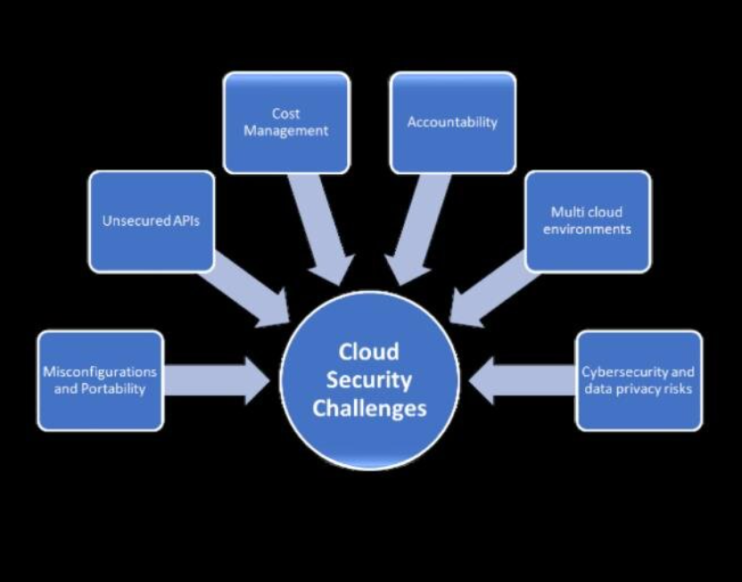

Cloud security systems must balance multiple factors such as security effectiveness, system performance, cost efficiency, and operational complexity.
10. Importance of Cloud Security Posture Management (CSPM) in Modern Cloud Environments
Cloud computing has become an essential part of modern information technology infrastructure. Organizations across the world are increasingly using cloud services to store data, run applications, and manage digital operations. Cloud platforms such as Amazon Web Services, Microsoft Azure, and Google Cloud Platform provide flexible and scalable environments that allow businesses to grow rapidly.

Understanding Cloud Security Posture Management
Cloud Security Posture Management refers to a set of automated tools and processes used to identify and fix security risks in cloud environments. It focuses mainly on detecting misconfigurations, enforcing compliance policies, and improving the overall security posture of cloud systems.

Importance of CSPM in Modern Cloud Environments

Prevention of Cloud Misconfigurations
One of the most important roles of CSPM is preventing cloud misconfigurations. Many cloud security breaches occur due to incorrect configuration settings.
Examples of common misconfigurations include:
- Publicly accessible storage buckets
- Unrestricted firewall rules
- Weak identity and access policies
- Disabled encryption
Continuous Security Monitoring
Modern cloud environments are dynamic and constantly changing. New resources such as servers, containers, and databases are frequently created and modified.
Improved Visibility and Control
Large organizations often use multiple cloud platforms and services. Managing security across such environments can be complex.
Compliance with Security Regulations
Organizations must comply with various security standards and regulations to protect user data and maintain trust. Examples include data protection laws and industry-specific security frameworks.
Risk Identification and Prioritization
Cloud environments may contain hundreds or thousands of resources. Not all security risks have the same level of impact.CSPM systems analyze risks and prioritize them based on severity. This allows security teams to focus on the most critical vulnerabilities first.
Integration with Other Security Systems
CSPM can integrate with other security solutions such as Endpoint Detection and Response (EDR), Security Information and Event Management (SIEM), and identity management systems.
Faster Incident Response
When a security risk or misconfiguration is detected, CSPM systems generate alerts and notifications. Security teams can quickly investigate and resolve the issue.
Some CSPM tools also support automated remediation, which reduces the time required to fix security problems.
Benefits of CSPM in Modern Cloud Environments
The use of CSPM provides several important benefits:
- Reduces risk of cloud misconfigurations
- Improves visibility across cloud infrastructure
- Ensures continuous compliance with regulations
- Enables automated security monitoring
- Enhances incident response capabilities
- Supports multi-cloud environments
- Strengthens overall security posture

11. Importance of cloud Scanning
Protection of Sensitive Data
One of the main reasons cloud security is important is to protect sensitive information stored in the cloud. Organizations store large amounts of confidential data, including customer records, financial information, and business documents.
Prevention of Cyberattacks
Cloud systems are connected to the internet, which makes them potential targets for cyberattacks. Attackers may attempt to exploit vulnerabilities in cloud applications or infrastructure.
Secure Access Control
Another important aspect of cloud security is controlling who can access cloud resources. Identity and Access Management (IAM) systems allow organizations to manage user identities and permissions.

Compliance with Regulations
Many organizations must follow strict legal and regulatory requirements related to data protection and privacy. Cloud security helps organizations meet these compliance standards.
Business Continuity and Disaster Recovery
Cloud security also helps organizations maintain business continuity. Security solutions include backup systems and disaster recovery mechanisms that allow organizations to recover data and restore services quickly in case of cyberattacks or system failures.
This ensures that business operations continue with minimal disruption.
Continuous Monitoring and Threat Detection
Modern cloud environments are dynamic and constantly changing. New applications, servers, and users are added regularly.Cloud security systems provide continuous monitoring of cloud activities. They analyze logs, network traffic, and system behavior to detect suspicious activities in real time.
Prevention of Misconfigurations
Many cloud security incidents occur due to configuration errors. For example, leaving storage systems publicly accessible or allowing unrestricted network access can expose sensitive data.
Support for Remote Access
Modern organizations often allow employees to work remotely. Cloud systems enable remote access to applications and data. Cloud security ensures that remote connections are secure through authentication systems, encryption, and endpoint protection. This allows employees to work safely from any location.

12. Data Protection & Privacy Measures
1. Data Encryption
- Encryption is one of the most important techniques used to protect cloud data. Encryption converts readable data into an unreadable format that can only be accessed using a decryption key.

2. Identity and Access Management (IAM)
- Identity and Access Management controls who can access cloud resources and what actions they can perform.
- Important IAM features include:
- Role-Based Access Control (RBAC)
- Multi-Factor Authentication (MFA)
- Single Sign-On (SSO)
- Least privilege access principle

3. Data Backup and Recovery
- Data protection also includes backup and disaster recovery mechanisms.
- Cloud systems automatically create backups of important data to prevent loss caused by cyberattacks, system failures, or accidental deletion.
- Backup systems allow organizations to restore their data quickly and continue operations without major disruptions.

4. Data Masking and Tokenization
- Data masking and tokenization techniques help protect sensitive information by replacing real data with anonymized or masked values.
- For example:
- Credit card numbers may be partially hidden
- Personal identifiers may be replaced with tokens

5. Secure Data Storage
Cloud providers implement secure storage systems that protect data from unauthorized access.
Security features may include:
- Secure storage containers
- Access control policies
- Encryption keys management
- Data integrity verification

Privacy Protection Measures
1 Data Privacy Policies
Organizations must implement clear privacy policies that define how personal data is collected, stored, and used.
Privacy policies ensure transparency and inform users about how their data is handled.
2 Compliance with Privacy Regulations
Cloud security systems must comply with various data protection regulations. These regulations ensure that organizations handle personal data responsibly.
Compliance frameworks may include:
- Data protection laws
- Industry security standards
- Privacy guidelines

3 User Consent and Data Control
Users should have control over their personal data. Organizations must obtain user consent before collecting or processing sensitive information.
Privacy systems may allow users to:
- View stored data
- Update personal information
- Request deletion of data

4 Monitoring and Audit Logging
Monitoring systems track all access and activities related to sensitive data.
Audit logs record important information such as:
- User login attempts
- Data access events
- Configuration changes

13. Objectives of a Web Application
in Cloud Security
Monitoring Cloud Infrastructure
One of the main objectives of a cloud security web application is to continuously monitor cloud infrastructure. This includes servers, storage systems, networks, databases, and applications.
The system collects security logs and configuration information from cloud resources and displays them in a centralized dashboard. Continuous monitoring helps security teams detect suspicious activities and vulnerabilities quickly.
Detecting Security Vulnerabilities
Cloud security web applications are designed to identify vulnerabilities that may expose cloud systems to cyberattacks.
Examples of vulnerabilities include:
- Publicly accessible storage systems
- Weak identity access policies
- Open firewall ports
- Unencrypted databases
Protecting Sensitive Data
Another important objective is protecting sensitive data stored in the cloud. Cloud environments often contain confidential information such as customer data, financial records, and business documents.
Security web applications help protect this data through:
- Encryption mechanisms
- Access control policies
- Data monitoring tools
Managing Identity and Access Control
Controlling user access to cloud resources is a critical part of cloud security. A web application helps manage identity and access policies.
Key access management features include:
- Role-Based Access Control (RBAC)
- Multi-Factor Authentication (MFA)
- User authentication systems
- Permission management

Ensuring Compliance with Security Standards
Organizations must comply with various legal and regulatory requirements related to data protection and cybersecurity.
Cloud security web applications help organizations maintain compliance by checking whether cloud configurations follow security guidelines and regulatory standards.
Providing Centralized Security Management
Cloud environments may include multiple services and platforms. Managing security across these systems can be complicated.
A web-based security application provides a centralized interface where administrators can view the security status of all cloud resources.
Real-Time Threat Detection
Another important objective is detecting cyber threats in real time. Security web applications analyze system logs, network traffic, and user activity to identify suspicious behavior.
When a potential threat is detected, the system sends alerts to administrators so they can investigate and respond quickly.
Automating Security Responses
Modern cloud security systems include automation features that allow them to respond to certain threats automatically.
For example:
- Blocking suspicious IP addresses
- Fixing configuration errors
- Isolating compromised systems
Improving Visibility and Reporting
Security teams need clear visibility into cloud operations. A cloud security web application provides dashboards and reports that display security metrics and system activity.
These reports help organizations analyze risks, identify trends, and make informed security decisions.
Benefits of Achieving These Objectives
When the objectives of a cloud security web application are achieved, organizations gain several advantages:
- Better protection of sensitive data
- Faster detection of cyber threats
- Improved compliance with security regulations
- Simplified security management
- Reduced risk of cloud misconfigurations
- Increased operational efficiency

14. Scope of web Application in
Cloud Security
- The scope of web applications in cloud security is broad and continues to expand with the increasing adoption of cloud technologies. These applications are used in various areas of cloud infrastructure management and cybersecurity.
- One important scope is cloud infrastructure monitoring. Security web applications continuously monitor cloud resources such as virtual machines, databases, storage systems, and networks. This monitoring helps detect suspicious activities and identify potential security risks in real time.
- Another important area is vulnerability detection and risk management. Cloud security web applications can scan cloud environments to detect misconfigurations, open ports, weak authentication settings, or outdated software. By identifying these vulnerabilities early, organizations can prevent cyberattacks and protect sensitive data.
- Web applications also play a significant role in identity and access management. They help organizations manage user accounts, permissions, and authentication systems. Features such as role-based access control and multi-factor authentication ensure that only authorized users can access cloud resources.
- Another major scope is data protection and privacy management. Cloud security web applications help protect sensitive information through encryption, secure storage mechanisms, and access control policies. These systems also maintain logs of user activities to track and prevent unauthorized access.
- In addition, cloud security web applications support compliance monitoring. Many organizations must follow data protection regulations and industry security standards. Security web applications can generate reports and analyze cloud configurations to ensure compliance with these requirements.

15. Scanning Process
Cloud Environment Data Collection
The first step in the scanning process is collecting data from cloud resources. CSPM tools connect to cloud environments through secure APIs provided by cloud platforms.
During this stage, the system gathers information about:
- Cloud servers and virtual machines
- Storage services and databases
- Network configurations
- Identity and access policies
- Security group settings
Configuration Assessment
Once the data is collected, CSPM tools analyze cloud configurations and compare them with recommended security standards and best practices.
The system checks for common security issues such as:
- Publicly accessible storage buckets
- Unrestricted firewall rules
- Disabled encryption settings
- Weak identity and access policies
Vulnerability Scanning
After configuration assessment, the system performs vulnerability scanning. This step focuses on identifying weaknesses in software, operating systems, and cloud services.
The scanning process examines:
- Outdated software versions
- Missing security patches
- Weak authentication mechanisms
- Known security vulnerabilities
Endpoint Monitoring with EDR
While CSPM scans cloud configurations, EDR focuses on monitoring endpoint devices connected to the cloud environment.
Endpoints may include:
- Cloud servers
- Virtual machines
- Employee computers
- Container environments
EDR continuously analyzes endpoint behavior and system activity to detect suspicious actions such as:
- Malware execution
- Unauthorized login attempts
- Abnormal network traffic
- File system changes
Threat Detection and Correlation
In this stage, CSPM and EDR systems work together to correlate collected data and identify potential security threats.
For example:
- CSPM may detect an exposed cloud server.
- EDR may detect suspicious activity on the same server.
Risk Analysis and Alert Generation
After analyzing the scanning results, the system evaluates the level of risk associated with each detected issue. The system prioritizes vulnerabilities based on their potential impact on the organization.

Automated Remediation
Many modern CSPM and EDR systems include automated remediation capabilities. These systems can automatically fix certain security issues without human intervention.
Examples of automated responses include:
- Blocking malicious IP addresses
- Isolating compromised endpoints
- Correcting insecure cloud configurations
- Applying security patches
Continuous Monitoring
Cloud environments are dynamic and constantly changing. Therefore, the scanning process is not a one-time activity. CSPM and EDR systems continuously scan cloud resources and endpoints to detect new risks and threats.

16. Proposed solution for Cloud Security Posture Management (CSPM) with Endpoint Detection & Response (EDR)
• Frontend Interface (Flask + HTML/CSS)
A user-friendly web dashboard that allows administrators to monitor cloud security posture, start scans, configure policies, and view alerts.
• Cloud Resource Scanner (CSPM Engine)
This module scans cloud resources and configurations to detect security misconfigurations.
• Endpoint Monitoring Agent (EDR Module)
The EDR module monitors endpoints such as cloud servers, virtual machines, and user devices. It collects system activity data including processes, file changes, login attempts, and network traffic to detect suspicious behavior.
• Threat Detection Engine
This component analyzes collected data from both cloud configurations and endpoints. It identifies potential threats such as malware, unauthorized access, abnormal system activity, and policy violations.
• Risk Analysis & Classification Module
Detected issues are evaluated and categorized based on severity levels such as Low, Medium, High, and Critical. The system prioritizes risks to help administrators respond quickly to the most serious threats.
• Automated Response Module
The system can automatically take corrective actions when threats are detected. Examples include blocking malicious IP addresses, isolating compromised endpoints, or fixing insecure cloud configurations.
• Security Report Generator
The system generates detailed security reports that include vulnerability findings, endpoint alerts, and remediation recommendations. Reports can be exported in JSON, CSV, and HTML formats with timestamps and scan IDs.
• Database Layer
Stores scan history, security findings, system logs, endpoint alerts, and configuration data. This database helps track security trends and provides historical records for audits and analysis.

Enhancements & Future Scope
• AI-Based Threat Detection
Artificial intelligence can be integrated to detect unknown threats and analyze complex attack patterns in cloud environments.
• Real-Time Security Dashboard
A live monitoring dashboard showing cloud posture status, endpoint alerts, and security heatmaps for better visualization of risks.
• Multi-Cloud Security Support
Support for multiple cloud platforms such as Amazon Web Services, Microsoft Azure, and Google Cloud Platform.
• Automated Compliance Monitoring
Automatic verification of cloud configurations against security standards and compliance frameworks.
• DevSecOps Integration
Integration with CI/CD pipelines to scan cloud infrastructure and applications during the development process.
• Role-Based Access Control (RBAC)
Allows multiple users with different roles such as administrators, security analysts, and auditors to access the system with controlled permissions.
• Threat Intelligence Integration
Integration with external threat intelligence feeds to detect known attack patterns and malicious IP addresses.
• Cloud Deployment & Scalability
Deploying the system on cloud infrastructure to support large-scale environments and ensure high availability.

17. Flowchart

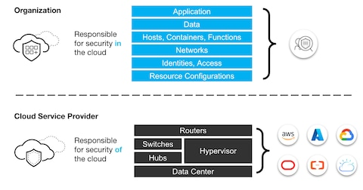

18. app.py – Main Flask App

requirements.txt

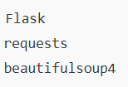

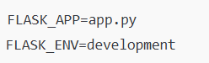

requirements.txt
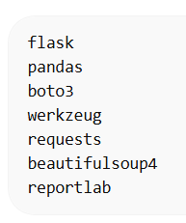

.flaskenv
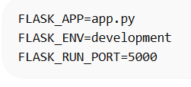

scanner/crawler.py
- Crawls the target website
Finds URLs, forms, and input fields

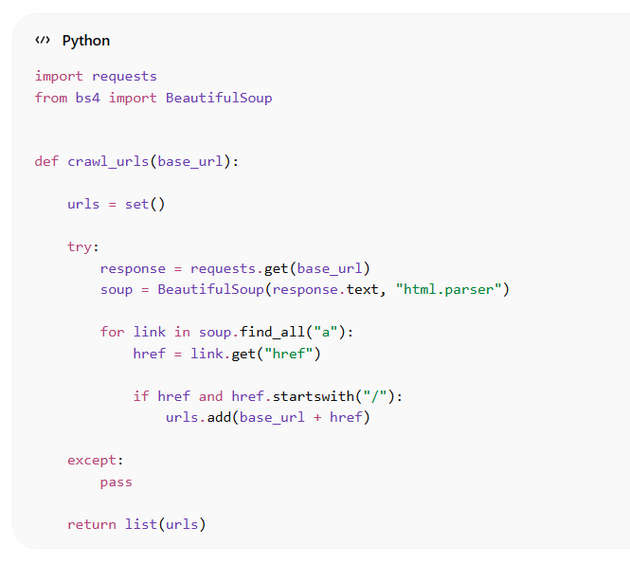

scanner/payloads.py
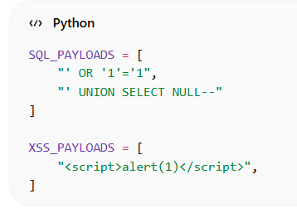

scanner/detectors.py
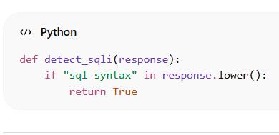

storage/repo.py
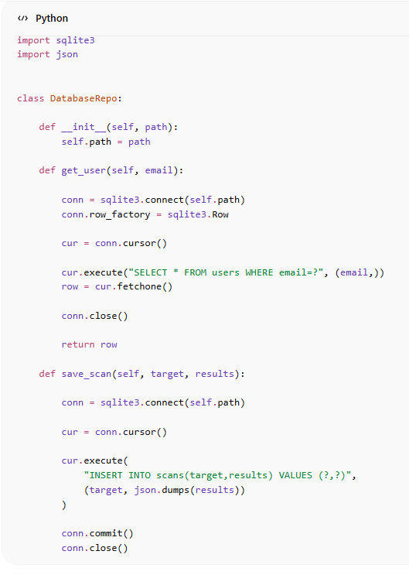

templates/
templates/login.html
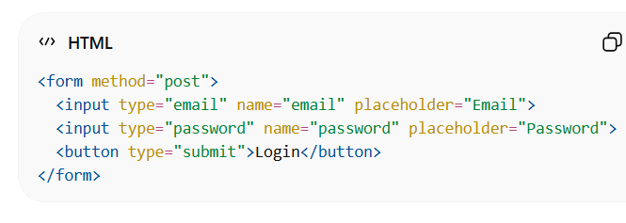
templates/dashboard.html
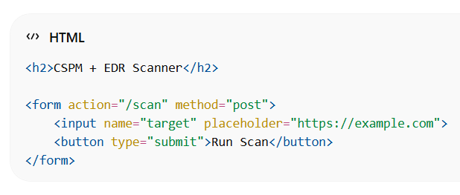

How to run the slide
- Opening the Project Folder

- Creating Virtual Environment

- Activating Virtual Environment

- Running the Flask App

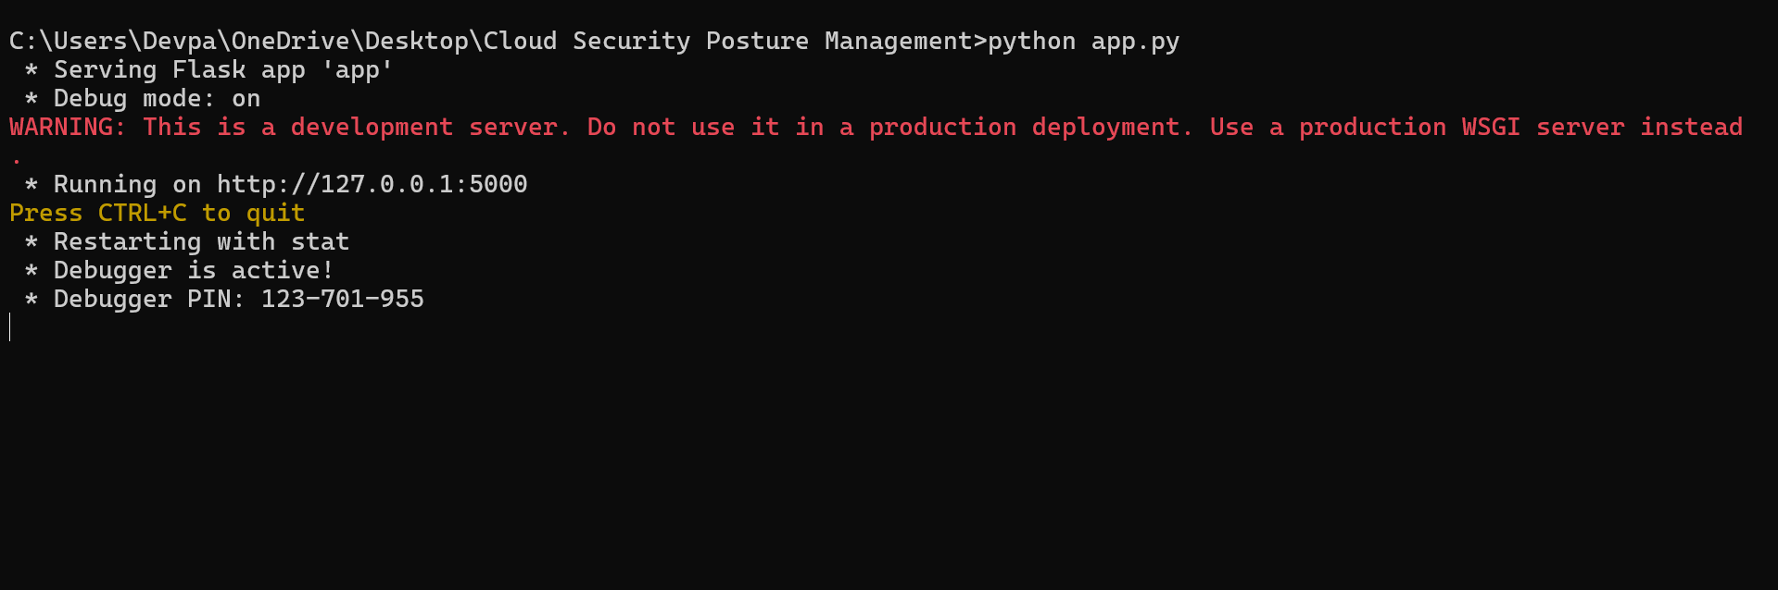

Running on http://127.0.0.1:5000

Start the Web Server
Open the browser at http://127.0.0.1:5000
The homepage loads
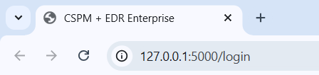

Login Page
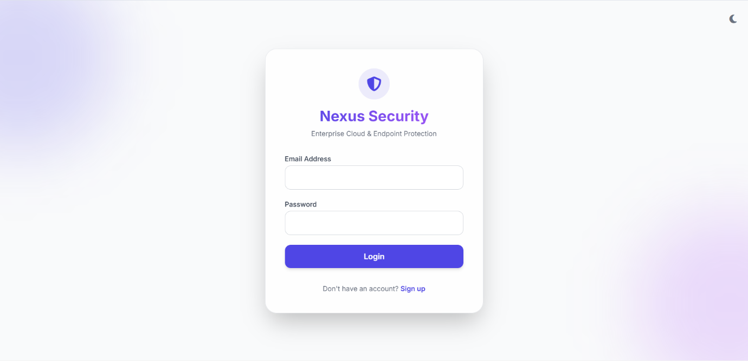

Sign in page
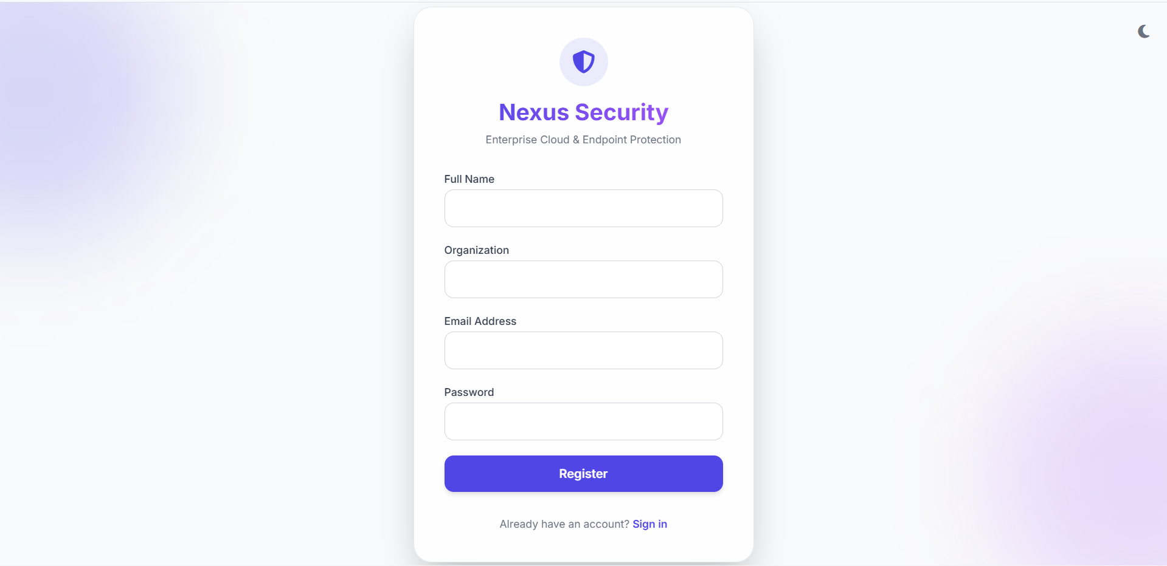
The Nexus Security Login Interface serves as the primary authentication gateway for accessing the Cloud Security Posture Management (CSPM) and Endpoint Detection and Response (EDR) platform. This interface ensures that only authorized users can access the enterprise security dashboard and system resources.
The login screen is designed with a modern minimalistic user interface, providing both usability and security. It includes fields for user credentials and integrates with the backend authentication system implemented using Flask session management and password hashing.

Run Scan Button

The Run Scan button is used to initiate a security scan of the cloud environment and connected endpoints. When the user clicks this button, the system starts analyzing resources to detect vulnerabilities, misconfigurations, and potential security threats. The scan collects data from services such as compute, storage, identity management, and databases. The results are then displayed on the dashboard with risk scores, alerts, and security recommendations.

Security Posture Analysis Dashboard
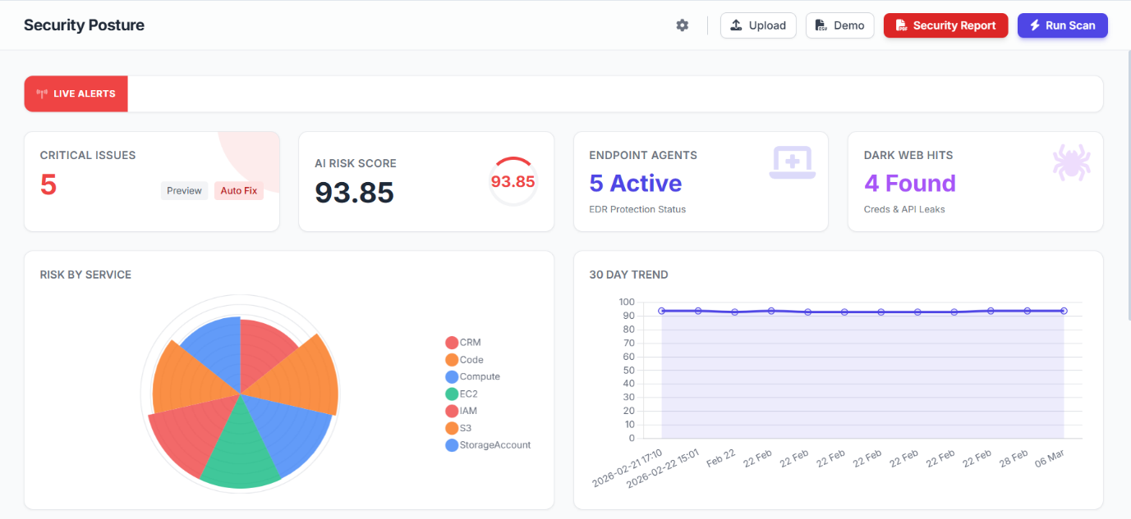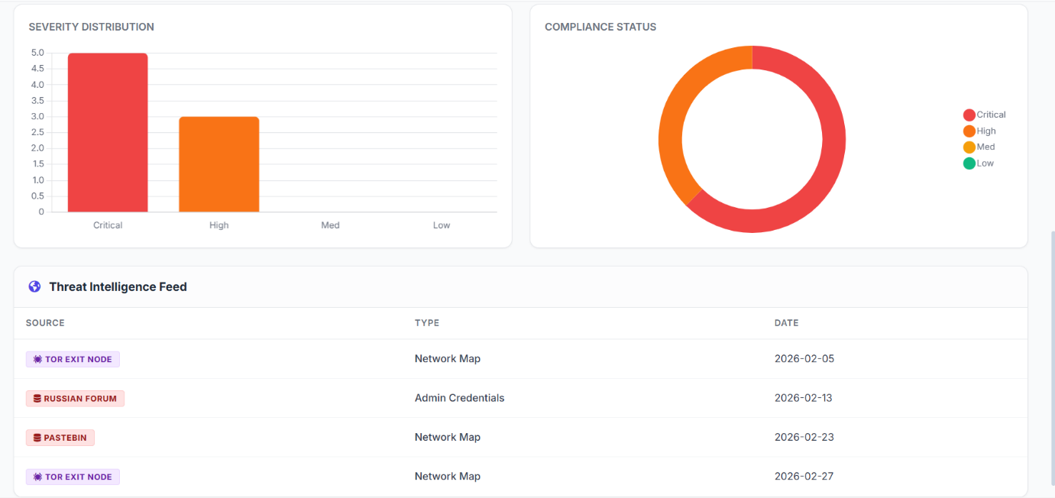
The Security Posture Analysis Dashboard provides a comprehensive overview of the organization's cloud security health and threat landscape. It highlights key indicators such as Critical Issues, AI Risk Score, Active Endpoint Agents, and Dark Web Hits, allowing administrators to quickly identify security risks.

The dashboard includes analytical visualizations like Risk by Service charts and 30-Day Trend graphs to monitor security performance over time. The Severity Distribution chart categorizes vulnerabilities into Critical, High, Medium, and Low levels for better prioritization.
Additionally, the Compliance Status panel shows the organization's adherence to security policies and frameworks. The Threat Intelligence Feed displays information gathered from external threat sources such as TOR nodes, forums, and paste sites.
Together, these components help security teams detect threats early, assess risks, and maintain a strong cloud security posture.
Detailed Security Findings
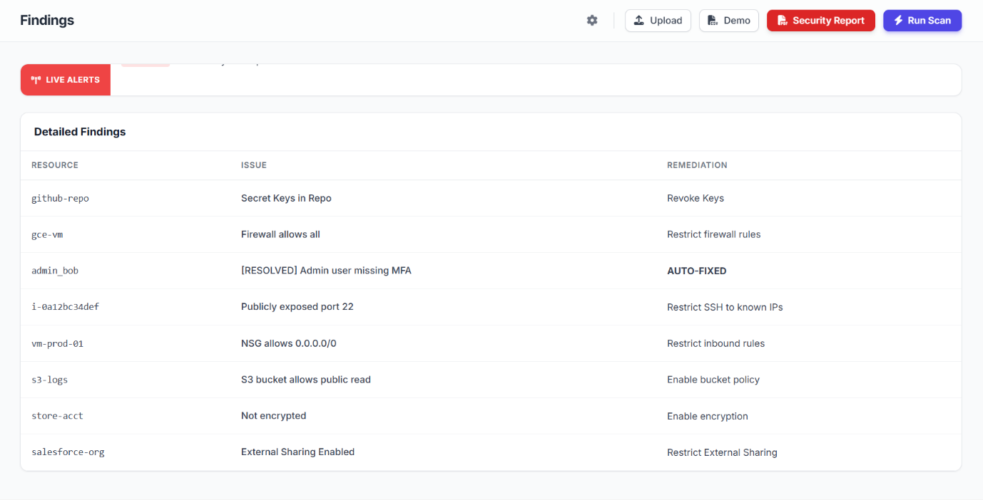
The Detailed Findings section displays a list of security vulnerabilities detected during the cloud security scan. It shows important information such as the affected resource, identified security issue, and recommended remediation steps. Examples of detected issues include exposed ports, missing multi-factor authentication (MFA), public S3 bucket access, weak firewall rules, and unencrypted storage. Each finding is analyzed by the system and presented with a suggested security action, such as restricting firewall rules, enabling encryption, or revoking exposed keys.
Asset Inventory Dashboard
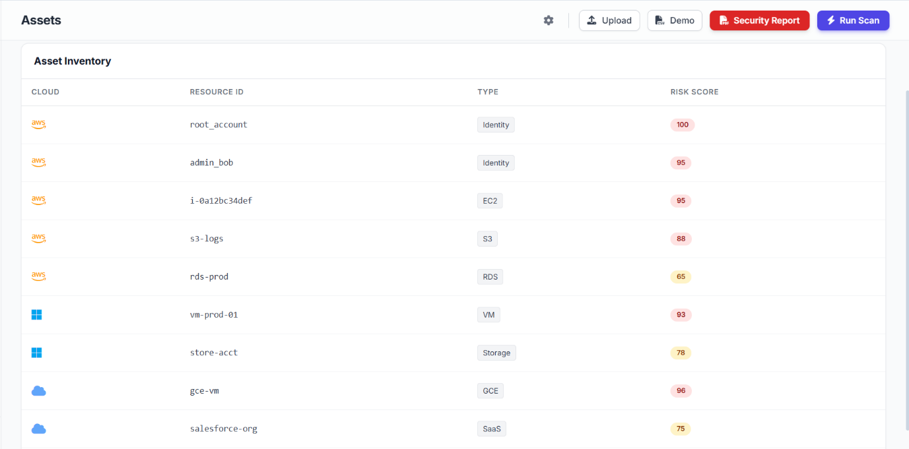
The Asset Inventory section provides a detailed list of all cloud resources monitored by the security platform. It displays important information such as the cloud provider, resource ID, resource type, and associated risk score for each asset. Resources may include services like AWS EC2 instances, S3 storage buckets, RDS databases, Azure virtual machines, and Google Cloud compute instances.
Endpoint Fleet Monitoring
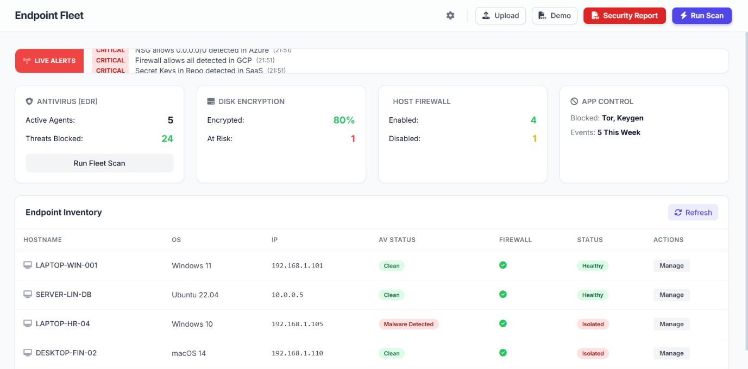
The Endpoint Fleet dashboard provides an overview of all connected devices monitored by the Endpoint Detection and Response (EDR) system. It displays important security information such as antivirus status, disk encryption level, host firewall configuration, and application control activity.
The platform tracks active agents and blocked threats to ensure endpoint protection across the organization. The Endpoint Inventory table lists devices with details like hostname, operating system, IP address, antivirus status, firewall status, and overall health.
Live Monitoring Dashboard
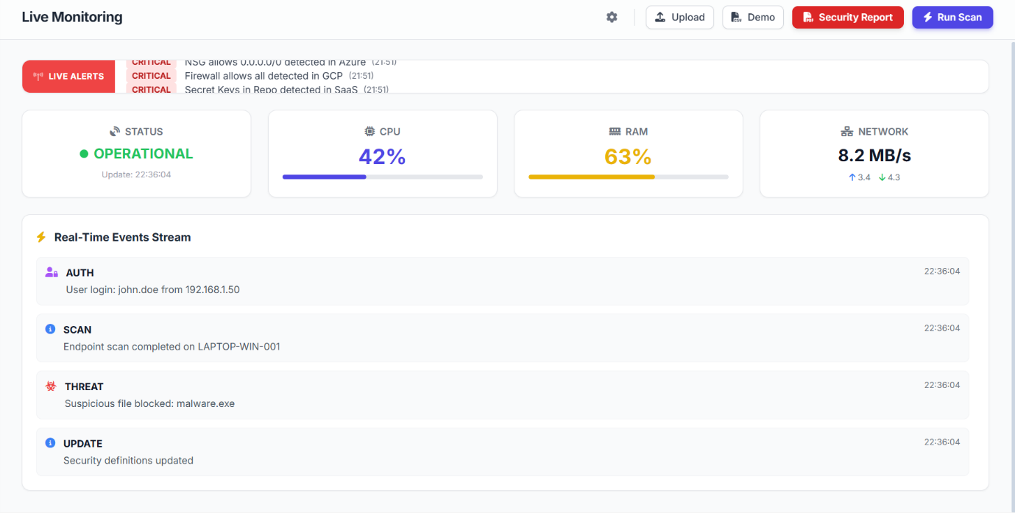
The Live Monitoring Dashboard provides real-time visibility into the system’s operational status and security activity. It displays important performance metrics such as CPU usage, RAM utilization, and network traffic, helping administrators monitor system health.
The dashboard also shows whether the security platform is operational and actively protecting the environment. A Real-Time Events Stream records ongoing activities such as user logins, endpoint scans, blocked threats, and security updates.

Threat Detection Dashboard
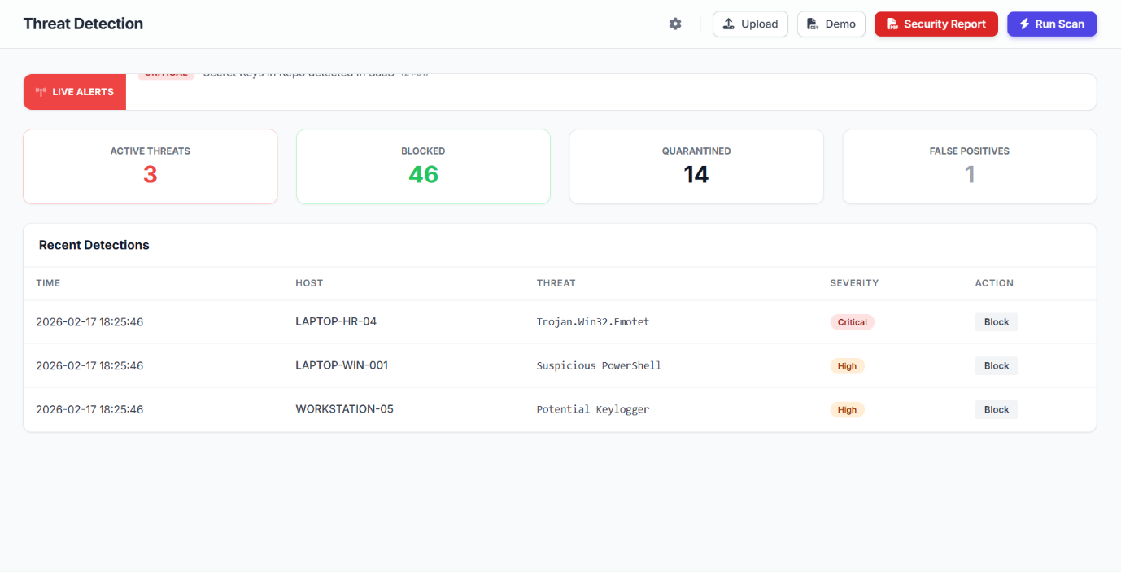
The Threat Detection Dashboard provides real-time visibility into malware and suspicious activities detected across the system. It displays key statistics such as the number of active threats, blocked attacks, quarantined files, and false positives.
The Recent Detections table lists details including the detection time, affected host device, type of threat, severity level, and recommended action. Examples of detected threats include malware like Trojan.Win32.Emotet, suspicious PowerShell activity, and potential keyloggers.

Dark Web Monitoring Dashboard
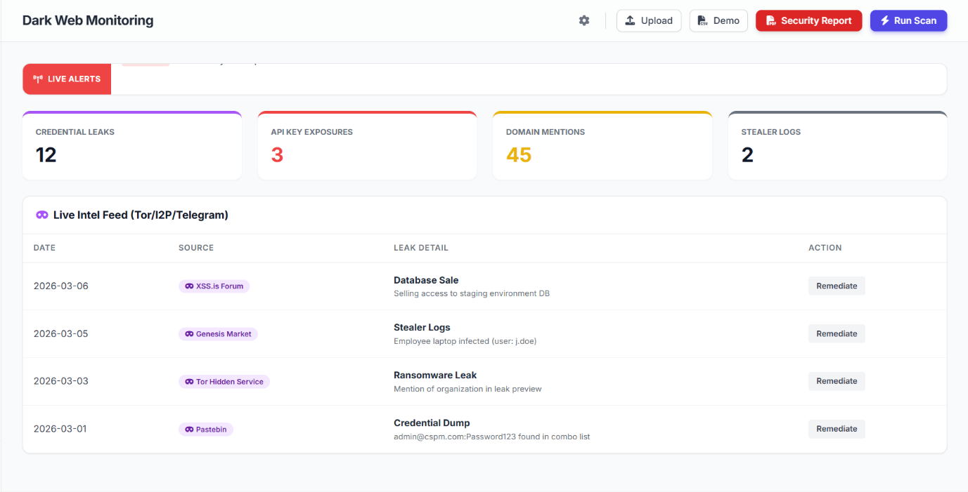
The Dark Web Monitoring Dashboard tracks potential security risks originating from hidden online sources such as Tor networks, underground forums, and paste sites. It identifies critical issues including credential leaks, exposed API keys, domain mentions, and stealer logs related to the organization.
The dashboard displays statistics that help security teams quickly assess the scale of data exposure. A Live Intelligence Feed shows detailed information about detected leaks, including the source, type of breach, and recommended remediation action.

Attack Graph Visualization
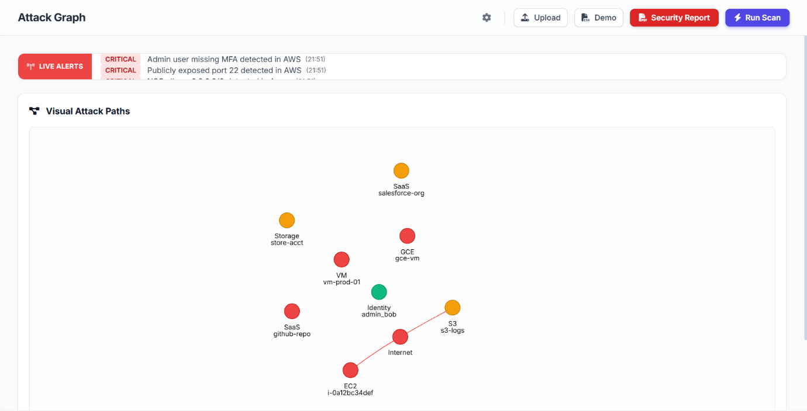
The Attack Graph module visualizes potential attack paths within the cloud environment and connected systems. It displays relationships between resources such as virtual machines, storage services, identities, SaaS applications, and internet access points.
Each node represents a resource, while the connecting lines show how attackers might move through the infrastructure if vulnerabilities exist. Critical assets and high-risk components are highlighted to help security teams understand possible attack routes. This visual representation allows administrators to quickly identify weak points in the network.

Compliance Monitoring Dashboard
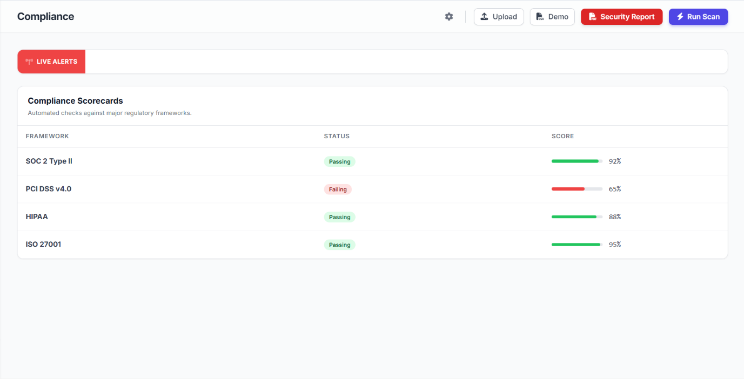
The Compliance Dashboard monitors the organization’s adherence to major security and regulatory frameworks. It performs automated security checks against standards such as SOC 2 Type II, PCI DSS v4.0, HIPAA, and ISO 27001.
Each framework is displayed with a compliance status and percentage score indicating how well the organization meets the required controls. A passing status shows that the system follows the recommended security policies, while a failing status highlights areas needing improvement.
These compliance scorecards help security teams identify gaps in policies and configurations.

Identity Governance Dashboard
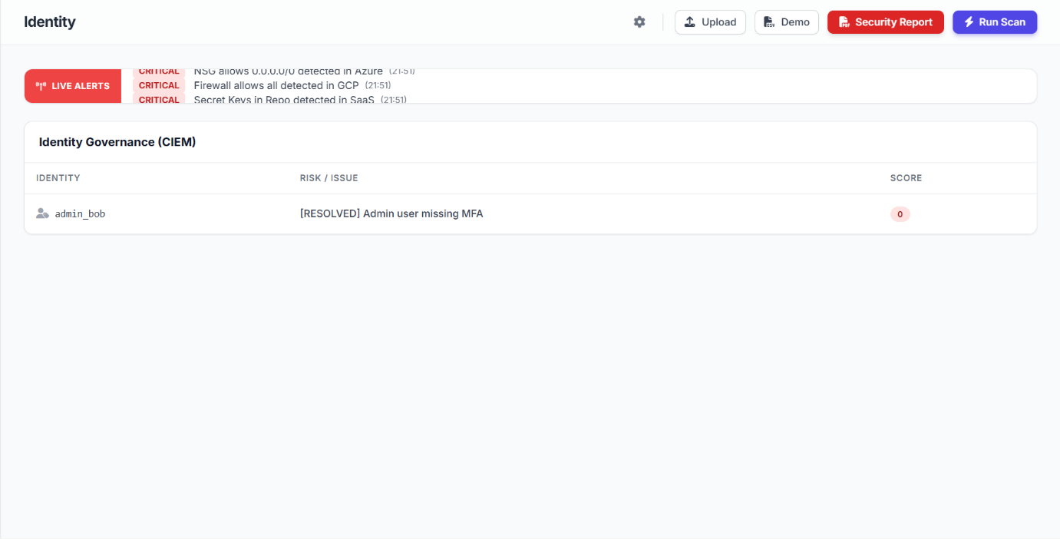
The Identity Governance (CIEM) dashboard manages and monitors user identities and access permissions across the cloud environment. It identifies potential risks related to user accounts, roles, and privileged access.
The system analyzes identity configurations and detects issues such as missing multi-factor authentication (MFA) or excessive permissions. Each identity is evaluated with a security score to measure its risk level.
The dashboard also tracks whether detected issues have been resolved or still require action.

Kubernetes Security Posture
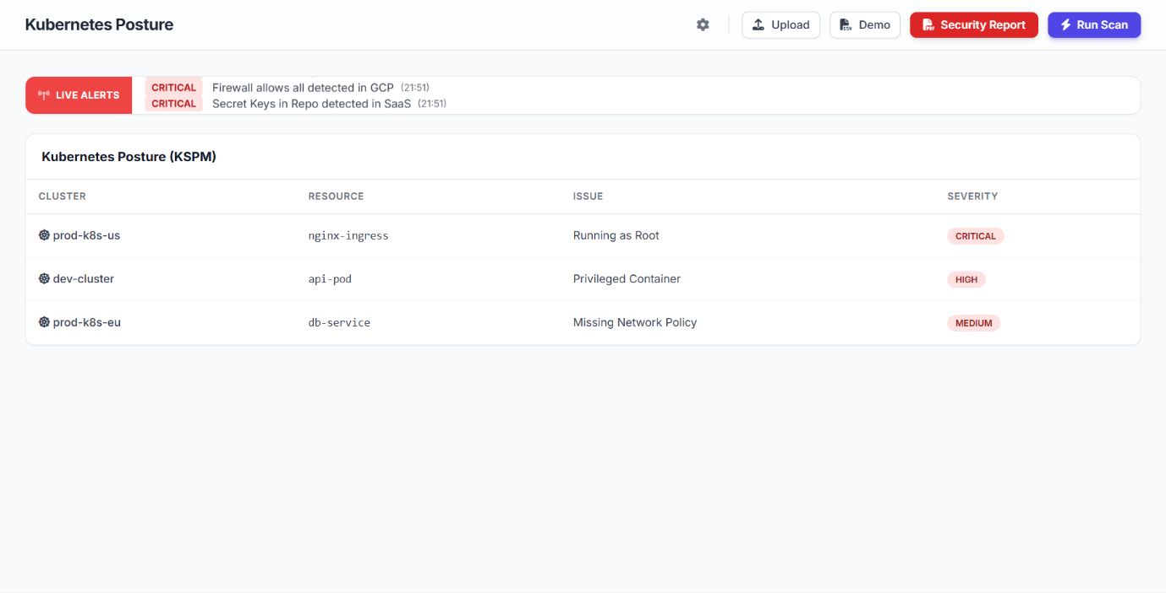
The Kubernetes Posture (KSPM) dashboard monitors the security configuration of Kubernetes clusters and containerized workloads. It identifies vulnerabilities and misconfigurations within cluster resources such as pods, services, and ingress controllers.
The system highlights issues like containers running as root, privileged containers, or missing network security policies. Each detected issue is categorized by severity levels such as Critical, High, or Medium to help prioritize remediation.

Platform Integrations Dashboard
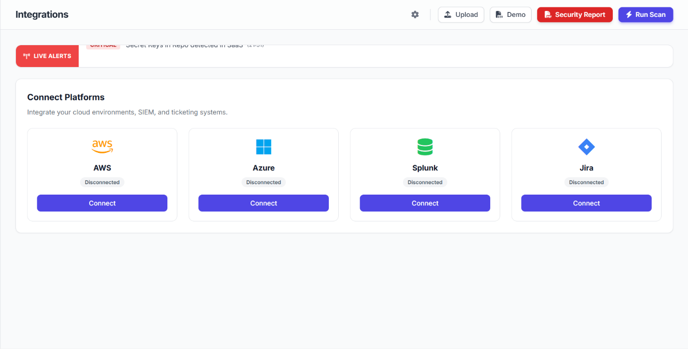
The Integrations Dashboard allows organizations to connect their cloud platforms and security tools with the security monitoring system. It supports integrations with services such as AWS, Microsoft Azure, Splunk, and Jira to enable centralized security management.
By connecting these platforms, the system can automatically collect logs, monitor cloud resources, and generate security alerts. Integration with SIEM tools like Splunk helps in advanced threat analysis and log management.
Ticketing systems such as Jira allow security teams to track and manage incident responses efficiently.

Security Policies and Frameworks
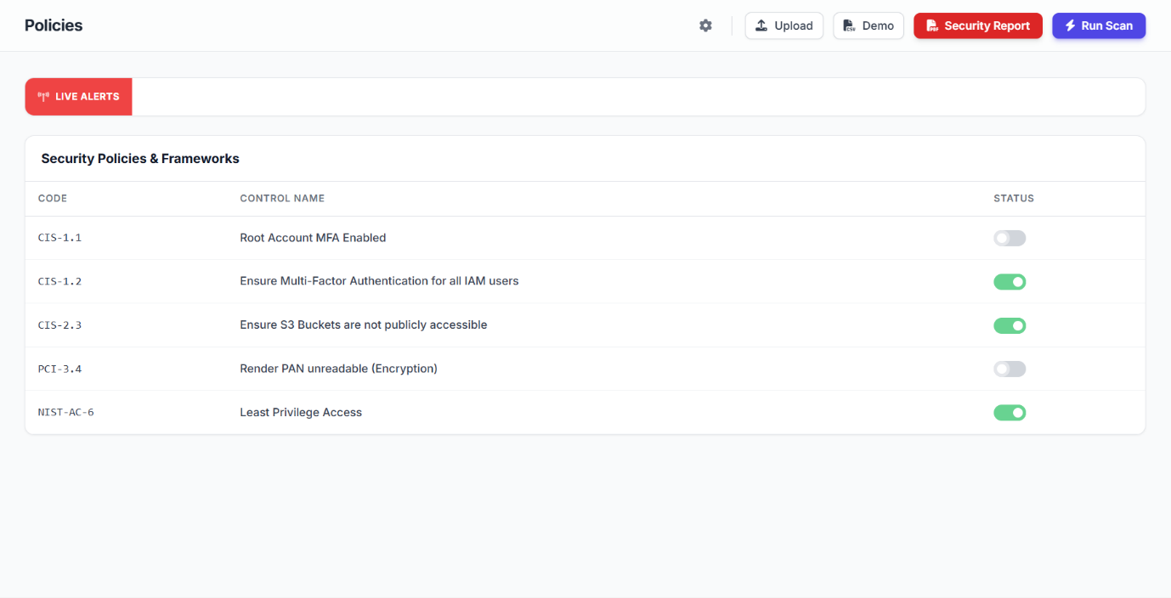
The Security Policies & Frameworks Dashboard allows administrators to manage and enforce security policies across the cloud environment. It displays policy controls based on well-known security standards such as CIS benchmarks, PCI DSS, and NIST frameworks.
Each policy includes a control code, description, and status indicating whether the rule is enabled or disabled. Examples include enabling MFA for root accounts, restricting public access to S3 buckets, and enforcing least privilege access.
Administrators can easily toggle policies to enforce security best practices.

Security Automation
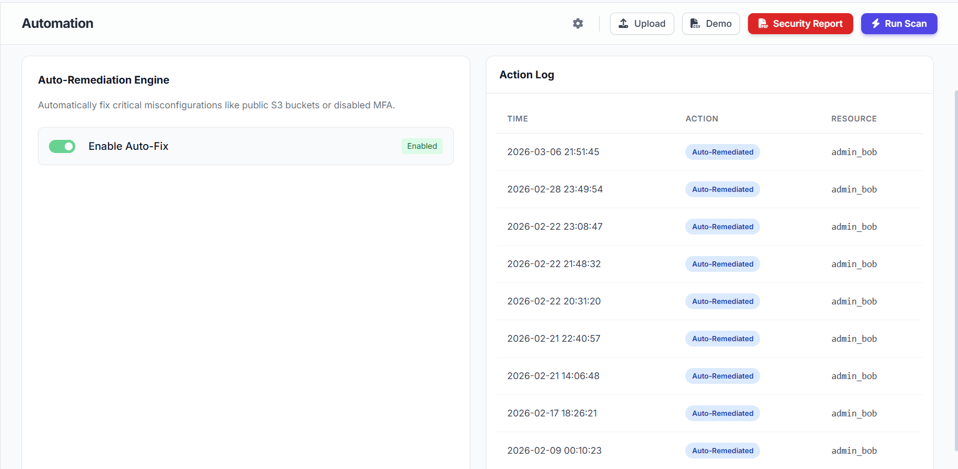
The Automation Dashboard manages automatic security remediation within the cloud security platform. It includes an Auto-Remediation Engine that automatically fixes critical security misconfigurations such as public S3 buckets, exposed ports, or disabled multi-factor authentication (MFA).
Administrators can enable or disable the Auto-Fix feature to allow the system to automatically correct detected issues. The Action Log records every automated remediation activity with details such as time, action performed, and affected resource.
This helps security teams track how vulnerabilities were resolved without manual intervention.

System Health Monitoring
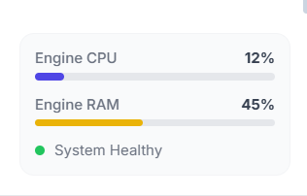
The System Health Monitoring panel displays the operational status and performance metrics of the security engine. It provides real-time information about CPU usage and RAM utilization, helping administrators monitor system performance.
These indicators ensure that the security platform is running efficiently without performance issues.
The panel also includes a System Health status indicator that shows whether the platform is functioning normally.
Monitoring these metrics helps detect resource overload or system instability early.

User Profile and API Access Management
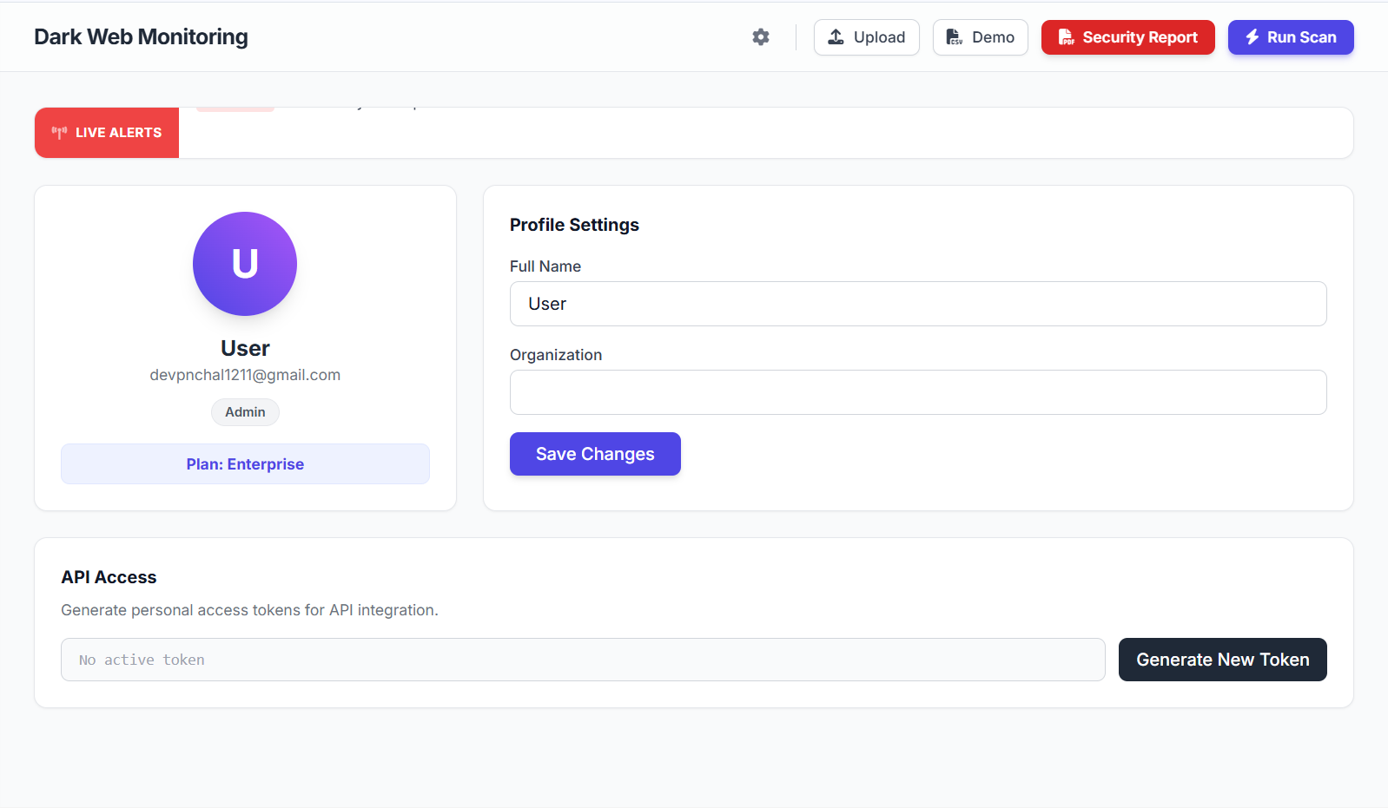
The User Profile and Settings Dashboard allows administrators to manage their account information and platform access. It displays user details such as name, email address, role, and subscription plan within the security platform.
Users can update their personal information and organization details through the profile settings panel. The dashboard also provides an API Access section where users can generate secure access tokens for integrating external applications and services.
These tokens enable secure communication between the security platform and other systems.

Security Report and Scan Controls

The Security Control Panel provides quick action buttons for managing security operations within the platform. The Upload button allows users to upload security logs or datasets for analysis.
The Demo option provides sample data to demonstrate the system’s functionality and features. The Security Report button generates a detailed report containing detected vulnerabilities, risk scores, and security insights.
The Run Scan button initiates a comprehensive security scan across cloud resources and endpoints.

Scanner Configuration Settings
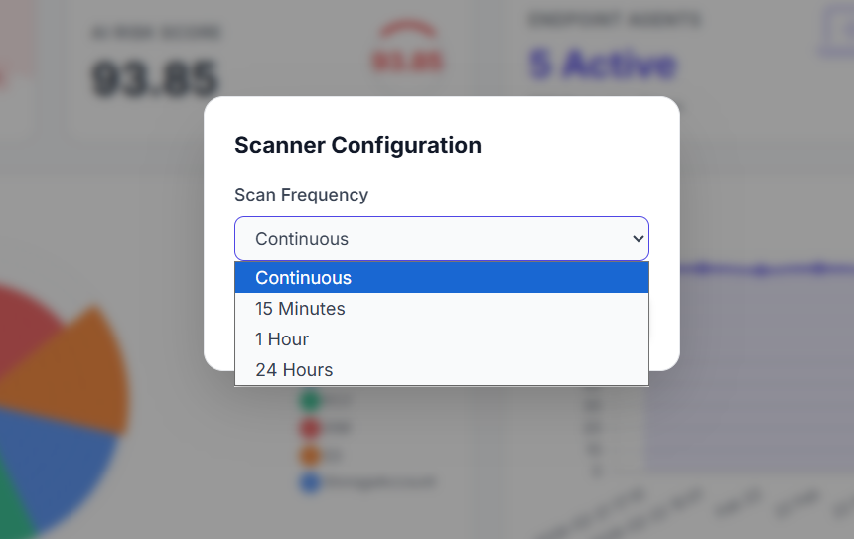
The Scanner Configuration panel allows administrators to define how frequently the security system performs automated scans. Users can choose different scan intervals such as Continuous, every 15 minutes, 1 hour, or 24 hours depending on their monitoring requirements.
Continuous scanning ensures real-time detection of vulnerabilities and configuration issues in cloud resources.
Scheduled scan intervals help organizations balance system performance with security monitoring

Security Report Generation
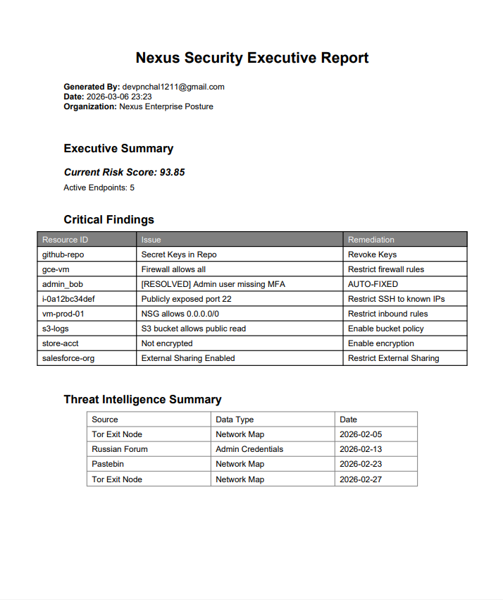

The Security Report feature generates a detailed executive report summarizing the organization’s overall security posture. It includes important information such as the current risk score, active endpoints, and key security findings detected during system scans.
The report highlights critical vulnerabilities, affected resources, and recommended remediation actions.
It also contains a Threat Intelligence Summary that provides insights into potential threats identified from external sources.

19. Future Enhancements of Cloud Security Posture Management (CSPM) with Endpoint Detection & Response (EDR)
1.What role will Artificial Intelligence play in future CSPM and EDR systems?
Artificial Intelligence (AI) will play an important role in improving threat detection and security analysis. AI-based security systems can analyze large volumes of cloud data and detect unusual patterns that may indicate cyber threats.
2. How will automation improve cloud security in the future?
Automation will allow cloud security systems to respond to threats without human intervention. Future CSPM and EDR solutions may automatically detect security misconfigurations and fix them instantly.
For example, if a storage bucket is accidentally configured as public, the system can automatically change the settings to private. Automation will reduce human errors and improve the speed of incident response.

3. Why is multi-cloud security an important future enhancement?
Many organizations use multiple cloud service providers to run their applications and services. Managing security across different cloud platforms can be difficult.
4. How will integration with DevSecOps improve security?
DevSecOps integrates security practices into the software development lifecycle. Future CSPM and EDR systems will be integrated with DevOps tools to scan applications and infrastructure during the development process.
5. What is behavioral analysis and how will it improve EDR systems?
Behavioral analysis involves monitoring the activities of users and systems to detect unusual behavior.
Future EDR systems will use advanced behavioral analytics to identify suspicious actions such as unusual login attempts, abnormal file access, or unexpected network traffic.
6. How will real-time dashboards improve cloud security management?
Future cloud security platforms will include advanced real-time dashboards that provide detailed visual insights into the security status of cloud environments.
These dashboards may include security graphs, risk heatmaps, and attack visualization tools.

20. Examples of Cloud Security Posture Management (CSPM) with Endpoint Detection & Response (EDR)
1. Public Cloud Storage Detection
CSPM detects a publicly accessible storage bucket in the cloud, while EDR monitors endpoints attempting to download sensitive data from that bucket.
2. Misconfigured Firewall Rules
CSPM identifies an open firewall port in the cloud environment, and EDR detects suspicious endpoint activity trying to exploit the open port.
3. Unauthorized Access Attempts
CSPM monitors identity and access management configurations, while EDR detects repeated failed login attempts from endpoint devices.
4. Malware Activity on Cloud Servers
CSPM ensures the cloud server is configured securely, while EDR detects malware processes running on the server endpoint.
5. Suspicious Network Traffic
CSPM monitors network configuration policies, and EDR detects abnormal network traffic generated by compromised endpoints.
6. Data Leakage Prevention
CSPM detects misconfigured cloud storage permissions, while EDR identifies endpoints attempting to transfer sensitive files outside the network.
7. Outdated Cloud Software
CSPM detects outdated software versions on cloud resources, and EDR monitors endpoint activities attempting to exploit those vulnerabilities.

8. Unauthorized Cloud Resource Creation
CSPM detects unauthorized creation of virtual machines in the cloud, while EDR tracks the endpoint that initiated the deployment.
9. Privilege Escalation Detection
CSPM detects changes in cloud access permissions, and EDR identifies suspicious endpoint processes attempting privilege escalation.
10. API Security Monitoring
CSPM analyzes cloud API configurations, while EDR detects malicious scripts running on endpoints that attempt to misuse the APIs.
11. Container Security Monitoring
CSPM scans container configurations in the cloud, while EDR monitors the container host systems for abnormal behavior.
12. Ransomware Detection
CSPM verifies cloud backup configurations, while EDR detects ransomware activity on endpoint devices before data is encrypted.
13. Cloud Compliance Monitoring
CSPM checks cloud environments for compliance violations, while EDR monitors endpoints for actions that may violate security policies.
14. Insider Threat Detection
CSPM monitors user access permissions in cloud systems, while EDR tracks suspicious actions performed by internal users on endpoints.
15. Cloud Configuration Change Monitoring
CSPM detects unauthorized changes in cloud configuration settings, and EDR identifies the endpoint responsible for those changes.

21. Future Enhancements (AI-based detection, CI/CD integration)

For Cloud Security Posture Management (CSPM) with Endpoint Detection & Response (EDR))
AI-Based Threat Detection
Artificial Intelligence (AI) is expected to play a significant role in the future of cloud security systems. AI-based detection systems can analyze large amounts of security data generated from cloud infrastructure and endpoint devices.
Machine learning algorithms can identify unusual patterns and behaviors that may indicate cyber threats such as malware infections, unauthorized access attempts, or data exfiltration.
For example, AI-based CSPM systems can automatically detect abnormal changes in cloud configurations or suspicious network activity. Similarly, AI-powered EDR systems can analyze endpoint behavior to detect previously unknown threats that traditional signature-based systems may fail to identify.
The use of AI in cloud security offers several benefits:
- Faster threat detection
- Reduced false positives and false negatives
- Automated analysis of security alerts
- Detection of zero-day vulnerabilities
- Improved response to advanced cyberattacks
CI/CD Integration (DevSecOps)
Another important future enhancement is the integration of CSPM and EDR with Continuous Integration and Continuous Deployment (CI/CD) pipelines. CI/CD pipelines are widely used in modern software development to automate the process of building, testing, and deploying applications.
By integrating security tools into CI/CD pipelines, organizations can implement DevSecOps, which means incorporating security practices directly into the development lifecycle.
In this approach, security scans are performed automatically during each stage of application development. For example:
- When developers commit code, security tools scan the code for vulnerabilities.
- During the build process, CSPM tools check cloud infrastructure configurations.
- Before deployment, EDR systems verify endpoint security conditions.
This ensures that security issues are detected early in the development process, reducing the risk of vulnerabilities being introduced into production environments.

22. Real-World Cloud Attack Examples
Capital One Data Breach (2019)
One of the most famous cloud security incidents occurred in 2019 when Capital One experienced a major data breach affecting over 100 million customers.
The attack was caused by a misconfigured firewall in the cloud environment hosted on Amazon Web Services. The attacker exploited the vulnerability to access sensitive customer data stored in cloud storage.
The stolen data included:
- Names
- Addresses
- Credit scores
- Social security numbers (in some cases)
This attack highlighted the importance of monitoring cloud configurations and implementing strong access controls.
Lesson Learned:
Proper configuration monitoring tools such as CSPM could have detected the misconfigured firewall before the attack occurred.

3. Tesla Cloud Data Exposure (2018)
In 2018, Tesla experienced a cloud security issue when attackers gained access to a misconfigured cloud server. The server was running on a cloud platform and contained sensitive internal data.
The attackers also installed cryptocurrency mining software on Tesla’s cloud infrastructure, using company resources for unauthorized activities.
This incident was caused by:
- Weak authentication
- Exposed cloud management interface
- Lack of proper monitoring
Lesson Learned:
Strong authentication mechanisms and endpoint monitoring tools like EDR could help detect suspicious activities on cloud servers.

4. Uber Cloud Data Breach (2016)
Uber suffered a cloud-related data breach in 2016 when attackers accessed private credentials stored in a code repository. These credentials allowed attackers to access Uber’s cloud storage environment.
The attackers downloaded personal information of approximately 57 million users and drivers.
The breach occurred because sensitive access keys were stored insecurely.
Lesson Learned:
Proper identity and access management policies and secure credential storage are essential for protecting cloud environments.

5. Microsoft Azure Cosmos DB Exposure (2021)
In 2021, a vulnerability in Microsoft Azure’s Cosmos DB database service exposed sensitive customer data belonging to thousands of organizations.
Researchers discovered that the vulnerability allowed attackers to access database credentials and potentially gain access to stored data.
Although the vulnerability was quickly patched, it demonstrated how cloud service vulnerabilities can affect multiple organizations.
Lesson Learned:
Continuous vulnerability monitoring and rapid security updates are essential for maintaining cloud security.

6. Code Spaces Cloud Attack (2014)
Code Spaces was a company that relied entirely on cloud infrastructure to host its services. In 2014, attackers gained access to the company's cloud management console.
The attackers deleted critical data, backups, and server configurations from the cloud environment. As a result, the company lost most of its operational data and was forced to shut down.
This attack demonstrated the devastating impact of compromised cloud administrator credentials.
Lesson Learned:
Strong authentication, multi-factor authentication (MFA), and access monitoring are critical for protecting cloud management accounts.

7. Snapchat Cloud Data Leak
Snapchat also experienced a cloud-related security incident when attackers accessed employee information stored in the cloud.
The attackers used phishing techniques to trick an employee into revealing login credentials. This allowed them to access sensitive payroll information.
Lesson Learned:
Security awareness training and endpoint protection are important for preventing phishing-based attacks.

8. Importance of CSPM and EDR in Preventing Cloud Attacks
Many of these real-world cloud attacks occurred due to:
- Misconfigured cloud settings
- Weak access controls
- Lack of continuous monitoring
- Compromised endpoint devices
Security solutions such as CSPM and EDR help prevent these attacks by:
- Monitoring cloud configurations for vulnerabilities
- Detecting suspicious endpoint activities
- Alerting administrators about security risks
- Automating threat detection and response
These technologies play a crucial role in protecting modern cloud environments from cyber threats.

23. Conclusion
- Cloud computing has become an essential part of modern information technology infrastructure. Organizations across various industries rely on cloud platforms to store data, run applications, and manage business operations efficiently. While cloud computing offers numerous benefits such as scalability, flexibility, and cost efficiency, it also introduces significant security challenges.

- This project focused on implementing a cloud security solution by integrating Cloud Security Posture Management (CSPM) with Endpoint Detection & Response (EDR) technologies. The main objective of the project was to design and develop a system capable of monitoring cloud infrastructure, detecting configuration vulnerabilities, identifying endpoint threats, and improving the overall security posture of cloud environments.

- CSPM plays a vital role in identifying and managing security risks within cloud environments. It continuously scans cloud configurations and compares them with recommended security standards and best practices. This helps organizations detect security misconfigurations such as publicly exposed storage, weak access control policies, and insecure network configurations.

- Endpoint Detection & Response, on the other hand, focuses on monitoring endpoint devices such as servers, virtual machines, and user systems connected to cloud infrastructure. EDR systems analyze endpoint behavior and detect suspicious activities such as malware infections, unauthorized access attempts, and abnormal network traffic.

- The integration of CSPM and EDR provides a comprehensive cloud security framework. While CSPM focuses on configuration-level security and compliance monitoring, EDR focuses on runtime threat detection and endpoint protection.

- Throughout the development of this project, several important cloud security concepts were explored, including vulnerability scanning, configuration monitoring, threat detection, compliance management, and automated security reporting.
24. Cloud Security Posture Management (CSPM) with Endpoint Detection & Response (EDR) – Quiz
1. What is Cloud Security Posture Management (CSPM)?
Answer. Cloud configuration monitoring
2. What is Endpoint Detection and Response (EDR)?
Answer. Endpoint threat detection
3. How does CSPM help improve cloud security?
Answer. CSPM improves cloud security by continuously scanning cloud resources and detecting misconfigurations.
4. What types of security risks can CSPM detect in cloud environments?
Answer. Cloud misconfigurations detection
5. How does EDR monitor endpoint devices for threats?
Answer. EDR monitors system behavior, processes, and network activity on endpoint devices to detect suspicious actions.
6. Why is configuration monitoring important in cloud security?
Answer. Prevent security risks
7. How does CSPM help organizations maintain compliance with security standards?
Answer. Compliance monitoring tools
8. What types of cyber threats can EDR detect on endpoint devices?
Answer. EDR can detect threats such as malware, ransomware, unauthorized access, and suspicious processes.
9. How does the integration of CSPM and EDR improve overall cloud security?
Answer. Integrated threat protection
10. What is the role of real-time monitoring in CSPM systems?
Answer. Continuous security monitoring
11. How can misconfigured cloud storage create security vulnerabilities?
Answer. Misconfigured cloud storage can expose sensitive data to unauthorized users or the public.
12. What is the importance of vulnerability scanning in cloud environments?
Answer. Identify security weaknesses
13. How does EDR respond when suspicious activity is detected on an endpoint?
Answer. Endpoint threat isolation
14. Why is endpoint security important in modern cloud infrastructures?
Answer. Endpoint security prevents compromised devices from being used to access cloud systems.
15. How can CSPM help prevent unauthorized access to cloud resources?
Answer. Access policy monitoring
16. What role does automation play in cloud security posture management?
Answer. Automated threat detection
17. How can behavioral analysis improve threat detection in EDR systems?
Answer. Behavioral analysis identifies unusual activities that may indicate cyber attacks.
18. What types of cloud services can be monitored using CSPM tools?
Answer. Cloud infrastructure services
19. How does CSPM help organizations identify compliance violations?
Answer. Security compliance checks
20. Why is combining CSPM and EDR important for modern cybersecurity strategies?
Answer. Comprehensive security protection

25. Bibliography
1. Microsoft Documentation – Cloud Security Posture Management (CSPM)
https://learn.microsoft.com/en-us/azure/defender-for-cloud/concept-cloud-security-posture-management
2. Amazon Web Services – What is Cloud Security Posture Management?
https://aws.amazon.com/what-is/cspm/
3. Palo Alto Networks – What is Cloud Security Posture Management (CSPM)?
https://www.paloaltonetworks.com/cyberpedia/what-is-cloud-security-posture-management
4. Google Cloud Documentation – Security Posture Management Overview
https://docs.cloud.google.com/security-command-center/docs/security-posture-overview
5. Orca Security – Cloud Security Posture Management (CSPM) Guide
https://orca.security/platform/cloud-security-posture-management-cspm/

6. Aqua Security – Cloud Security Posture Management Explained
https://www.aquasec.com/cloud-native-academy/cspm/cloud-security-posture-management-cspm/
7. Rubrik – Cloud Security Posture Management Overview
https://www.rubrik.com/insights/cloud-security-posture-management
8. Broadcom Security – CSPM Technical Documentation
https://techdocs.broadcom.com/us/en/symantec-security-software/information-security/symantec-cloudsoc/cloud/securlets-home/about-cloud-security-posture-management.html
9. Hyperproof – Complete Guide to Cloud Security Posture Management
https://hyperproof.io/resource/what-is-cloud-security-posture-management/
10. Cymulate – Cybersecurity Glossary: Cloud Security Posture Management
https://cymulate.com/cybersecurity-glossary/cloud-security-posture-management/
11. Gartner Research – Cloud Security Posture Management Tools Overview
https://www.gartner.com/reviews/market/cloud-security-posture-management-tools
12. AWS Security Hub Documentation – CSPM in AWS Security Hub
https://docs.aws.amazon.com/securityhub/latest/userguide/what-is-securityhub.html
13. ResearchGate – Cloud Security Posture Management Tools and Techniques
https://www.researchgate.net/publication/385694719_Cloud_security_posture_management_tools_and_techniques

14. Ollion – Revolutionize Your Cloud Security with CSPM
https://ollion.com/articles/revolutionize-your-cloud-security
15. Elastic Security – Getting Started with CSPM for Google Cloud
https://www.elastic.co/docs/solutions/security/cloud/get-started-with-cspm-for-gcp



